
SMART DIGITAL GRAMA PANCHAYAT SERVICES
A MINI PROJECT REPORT
Submitted by
ABIN MATHEW
Reg.No: MLM25MCA-2005
To
the APJ Abdul Kalam Technological University
in Partial fulfillment of the requirements for
the award of the degree
of
MASTER OF COMPUTER APPLICATIONS
Under the Guidance of
Ms. ANJALY SAJEEV
(Assistant Professor, Department of Computer Applications)

DEPARTMENT OF COMPUTER APPLICATIONS
MANGALAM COLLEGE OF ENGINEERING, ETTUMANOOR
(Affiliated to APJ Abdul Kalam Technological University)
OCTOBER 2026
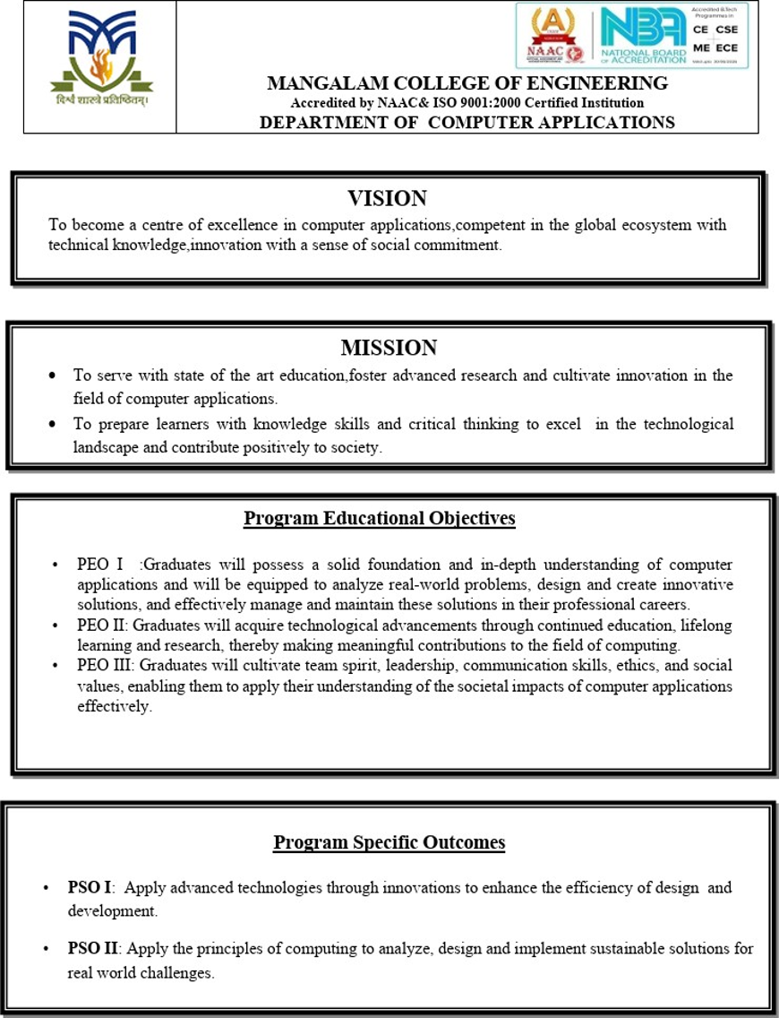

MAPPING OF PO – PSO – SDG

LIST OF PROGRAMME OUTCOMES (POs)
PO1 (Foundation Knowledge): Apply programming logic, database concepts and web-development fundamentals to solution architecture and problem solving.
PO2 (Problem Analysis): Identify, review and analyse limitations of manual Panchayat service delivery with emphasis on citizen requirements.
PO3 (Development of Solutions): Design and develop innovative digital solutions that improve local-government service access and traceability.
PO4 (Modern Tool Usage): Select and apply modern frameworks, databases, modelling tools and security mechanisms for practical systems.
PO5 (Individual and Teamwork): Plan, communicate and execute software work effectively during analysis, development, testing and documentation.
PO6 (Project Management): Apply planning, scheduling, modular decomposition and risk management principles to project execution.
PO7 (Ethics): Protect citizen information using responsible access control, privacy-aware verification and secure data-handling practices.
PO8 (Life-long Learning): Learn and adapt contemporary technologies for improving digital public-service systems.

- MAPPING WITH PROGRAMME OUTCOMES (POs)
Sl. No | POs Addressed | Relevance to Project
1 | PO1 – Foundation Knowledge | Uses Python, Django, relational modelling, HTML/CSS/JavaScript, QR generation and report generation to build a working service portal.
2 | PO2 – Problem Analysis | Analyses delays, fragmented paper records, lack of application visibility and manual complaint/waste workflows.
3 | PO3 – Development of Solutions | Implements a unified portal for certificates, complaints, waste collection, notifications, announcements and disaster alerts.
4 | PO4 – Modern Tool Usage | Applies Django ORM, ReportLab, QRCode/Pillow, Bootstrap-compatible UI, jsQR, Git and automated tests.
5 | PO6 – Project Management | Uses modular development, staged implementation, validation and documentation suitable for a mini-project schedule.
6 | PO7 – Ethics | Uses authenticated access, role checks, private file handling, limited public verification data and audit history.
7 | PO5 – Individual & Teamwork | Demonstrates coordinated analysis, design, implementation, testing and presentation activities.
8 | PO8 – Life-long Learning | Extends coursework through certificate fingerprinting, atomic workflows, safety alerts, CSV export and SMS-outbox design.

2. MAPPING WITH PROGRAMME SPECIFIC OUTCOMES (PSOs)

Sl. No | PSOs Addressed | Relevance to Project
1 | PSO1 – Advanced technologies through innovation | Django MVT architecture, QR/PDF certificate generation, private uploads, workflow validation, audit updates and optional SMS support improve the efficiency of Panchayat service handling.
2 | PSO2 – Sustainable real-world computing solutions | A modular open-source web architecture digitizes common rural-governance workflows with low software licensing cost and clear scalability paths.
PSO 1: Apply advanced technologies through innovations to enhance the efficiency of design development.
PSO 2: Apply the principles of computing to analyze, design and implement sustainable
solutions for real world challenges

3. MAPPING WITH SUSTAINABLE DEVELOPMENT GOALS (SDGs)

SDG No | SDG Addressed | Relevance to Project
SDG 9 | Industry, Innovation & Infrastructure | Builds a modern digital service infrastructure using open-source web technologies, structured databases and reusable workflow modules.
SDG 11 | Sustainable Cities & Communities | Supports accessible local services, complaint handling, waste collection coordination and public information for rural communities.
SDG 13 | Climate Action | Implements an official safety/disaster alert workflow with ward targeting, action instructions and optional SMS delivery support.
SDG 16 | Peace, Justice & Strong Institutions | Improves transparency and accountability through role-based access, status history, notifications, traceable decisions and QR verification.
SDG 10 | Reduced Inequalities | The English–Malayalam interface option reduces a language barrier for citizens and collection staff by making core service navigation and instructions available in Malayalam.

SUSTAINABLE DEVELOPMENT GOALS (SDGs)

SDG 1 – No Poverty: End poverty in all its forms everywhere.
SDG 2 – Zero Hunger: End hunger, achieve food security and promote sustainable agriculture.
SDG 3 – Good Health and Well-Being: Ensure healthy lives and promote well-being for all.
SDG 4 – Quality Education: Ensure inclusive and equitable quality education and lifelong learning.
SDG 5 – Gender Equality: Achieve gender equality and empower all women and girls.
SDG 6 – Clean Water and Sanitation: Ensure availability and sustainable management of water and sanitation.
SDG 7 – Affordable and Clean Energy: Ensure access to affordable, reliable and sustainable energy.
SDG 8 – Decent Work and Economic Growth: Promote sustained, inclusive and sustainable economic growth.
SDG 9 – Industry, Innovation and Infrastructure: Build resilient infrastructure and foster innovation.
SDG 10 – Reduced Inequalities: Reduce inequality within and among countries.
SDG 11 – Sustainable Cities and Communities: Make human settlements inclusive, safe, resilient and sustainable.
SDG 12 – Responsible Consumption and Production: Ensure sustainable consumption and production patterns.
SDG 13 – Climate Action: Take urgent action to combat climate change and its impacts.
SDG 14 – Life Below Water: Conserve and sustainably use oceans, seas and marine resources.
SDG 15 – Life on Land: Protect and restore terrestrial ecosystems and biodiversity.
SDG 16 – Peace, Justice and Strong Institutions: Build effective, accountable and inclusive institutions.
SDG 17 – Partnerships for the Goals: Strengthen implementation and global partnerships

MANGALAM COLLEGE OF ENGINEERING, ETTUMANOOR
DEPARTMENT OF COMPUTER APPLICATIONS
OCTOBER 2026
DECLARATION

I hereby certify that the work presented in the project entitled “SMART GRAMA PANCHAYAT SERVICES” submitted to the DEPARTMENT OF COMPUTER APPLICATIONS is an authentic record of my own work carried out under the supervision of Ms. Anjaly Sajeev, Assistant Professor. This work has not been submitted to any other institution or university for the award of any other degree. The report has been checked for plagiarism by the college and the similarity index is within the permissible limit set by the college.

Name & Signature of Student
Date: ABIN MATHEW
Place: MLM25MCA-2005

MANGALAM COLLEGE OF ENGINEERING, ETTUMANOOR
DEPARTMENT OF COMPUTER APPLICATIONS
OCTOBER 2026
CERTIFICATE

Certified that the report entitled “SMART DIGITAL GRAMA PANCHAYAT SERVICES” submitted by ABIN MATHEW (MLM25MCA-2005) to the APJ Abdul Kalam Technological University in partial fulfillment of the requirements for the award of the Degree of Master of Computer Applications is a bonafide record of the MINI PROJECT work carried out by the student under our guidance and supervision during the academic year 2025–27.

PROJECT GUIDE  Ms. Anjaly Sajeev Assistant Professor  Department of Computer Applications | PROJECT COORDINATOR  Ms. Athira R Kurup Assistant Professor  Department of Computer Applications
HEAD OF THE DEPARTMENT  Ms. Divya S B  HOD & Assistant Professor  Department of Computer Applications | EXTERNAL EXAMINER

ACKNOWLEDGEMENT
I am greatly indebted to the authorities of Mangalam College of Engineering for providing the necessary facilities to successfully complete my Project on the topic “Smart Grama Panchayat Services”.
I express my sincere thanks to Dr. Vinodh P Vijayan, Principal, Mangalam College of Engineering, for providing the facilities and support to complete my Project successfully.

I thank and express my sincere gratitude to Ms. Divya S B, HOD, Department of Computer Applications, Mangalam College of Engineering, for her invaluable help and support, which helped me a lot in successfully completing this Project work.

I express my gratitude to my Internal Guide, Ms. Anjaly Sajeev, Assistant Professor, Department of Computer Applications, for her valuable suggestions, guidance, and encouragement, which helped in the successful completion of my Project.

Furthermore, I would like to acknowledge with much appreciation the crucial role of the faculties, especially Project Coordinator, Ms. Athira R Kurup, Department of Computer Applications, Mangalam College of Engineering, who gave me the necessary guidance, permission, and resources required to complete the project presentation and report.

Finally, I would like to express my heartfelt thanks to my parents for their continuous support, encouragement, and motivation throughout the completion of this Project.
ABIN MATHEW
MLM25MCA-2005

ABSTRACT
Smart Digital Grama Panchayat Services is a web-based e-Governance platform developed to improve the accessibility, transparency and traceability of commonly used Gram Panchayat services. The project addresses practical limitations of manual processes such as repeated office visits, paper-based records, slow retrieval, limited application-status visibility and difficulty verifying issued documents. The system provides a single portal through which citizens can register, submit service requests, track progress and receive official responses.
The implementation uses Python and Django with server-rendered HTML, CSS, JavaScript and a relational database. The academic prototype supports birth, death, residence, property ownership and general certificate applications, categorized complaints, waste collection requests, citizen notifications, public announcements, administrative reports and role-based workspaces for citizens, officials and waste-collection staff. Supporting documents are stored outside the public static path and are served only after ownership or role checks.
The updated build also provides an English–Malayalam interface switch for citizen and waste-collector accounts. The selected preference is stored in the user profile and is restored on later visits. A Django language middleware, template translation filter, local Malayalam catalogue and browser-side translation helper translate interface labels, navigation items, service names, form guidance, status values and verification messages while leaving citizen-entered content unchanged. Panchayat officials continue to use the English administrative interface so operational terminology remains consistent.
An important feature is the certificate workflow. When an authorized official approves a certificate request, the application generates a fixed PDF containing a QR verification link. The issued document is stored with a SHA-256 fingerprint, allowing later comparison with an uploaded PDF and enabling revocation-aware public verification. Status changes are recorded through a workflow service that validates allowed transitions, creates history records and produces notifications inside a database transaction.
The project also includes a safety and disaster-alert subsystem. Authorized officials can create alerts with severity/action level, affected area, optional ward, safe-place information and public instructions. Recipient snapshots and optional SMS-outbox records provide a structured basis for targeted emergency communication without exposing citizen contact information publicly. Automated tests cover access control, workflow transitions, file validation, certificate immutability, revocation, CSV export and safety-alert behavior.
The completed project demonstrates how a modular role-based web application can improve citizen service visibility while reducing dependence on isolated manual records. It is an academic prototype rather than an official government service; real deployment would require approved government integration, HTTPS, production database configuration, backups, monitoring, security review, formal review of bilingual terminology and legal validation of certificate-signing procedures.

Keywords: e-Governance, Smart Grama Panchayat, Digital Citizen Services, Django, Role-Based Access Control, English–Malayalam Localization, QR Code Verification, SHA-256 Fingerprinting, Certificate Management, Workflow Automation, Complaint Management, Disaster Alerts.

TABLE OF CONTENTS
CHAPTER NO. TITLE PAGE NO.
MAPPING OF PO – PSO – SDG iii
ABSTRACT ix
LIST OF TABLES xii
LIST OF FIGURES xiii
LIST OF ABBREVIATIONS xiv
Chapter 1 INTRODUCTION 1
1.1 Background 1
1.2 Motivation 2
1.3 Scope and Objectives 3
1.4 Problem Statement 5
Chapter 2 REQUIREMENTS AND ANALYSIS 7
2.1 Existing System and Problem Statement 7
2.2 Solution Overview 8
2.3 Feasibility Study 10
2.4 Data Validation and Integrity 12
Chapter 3 LITERATURE REVIEW 14
3.1–3.10 Review of Ten Related Studies 14–17
Chapter 4 DIAGRAMS 21
4.1 Data Flow Diagrams 21
4.2 Use Case Diagram 24
4.3 Class Diagram 25
4.4 State Diagram 26
4.5 Activity Diagram 27
4.6 Sequence Diagram 28

CHAPTER NO. | TITLE | PAGE NO.
Chapter 5 | METHODOLOGY | 30
5.1 | Development Methodology | 30
5.2 | Module Descriptions | 30
5.3 | Algorithms and Business Rules | 39
5.4 | Architecture | 40
5.5 | Database Design | 41
5.6 | Case Study | 42
Chapter 6 | IMPLEMENTATION DETAILS | 43
6.1 | Implementation Procedures | 43
6.2 | Testing Methods and Results | 45
6.3 | Security Considerations | 47
6.4 | Deployment and Maintenance Procedure | 47
6.5 | Testing Summary and Acceptance Criteria | 48
6.6 | Data Management, Auditability and Record Retention | 48
6.7 | Error Handling and Operational Controls | 50
6.8 | Implementation Traceability to Requirements | 51
Chapter 7 | ADVANTAGES AND DISADVANTAGES | 52
Chapter 8 | RESULTS AND DISCUSSION | 54
8.1 | Analysis of Implemented Result | 55
8.2 | Discussion | 55
8.3 | Role-wise Result Discussion | 55
8.4 | Project Outcome | 56
8.5 | Detailed Functional Evaluation | 57
8.6 | Usability, Maintainability and Scalability Observations | 58
Chapter 9 | CONCLUSION | 59
9.1 | Summary | 59
9.2 | Limitations | 59
9.3 | Future Scope | 60
9.4 | Applications | 61
9.5 | Deployment Readiness Recommendations | 62
9.6 | Sustainability and Community Impact | 63
Chapter 10 | APPENDICES | 64
Chapter 11 | REFERENCES | 66

LIST OF TABLES
TABLE NO. | TITLE | PAGE NO.
Table 2.1 | Functional / Non-functional Requirements | 9
Table 2.2 | Feasibility Analysis | 11
Table 3.1 | Comparative Literature Summary | 19
Table 5.1 | Module Summary | 30
Table 5.2 | Database Entity Summary | 41
Table 6.1 | Software and Hardware Environment | 43
Table 6.2 | Test Cases and Results | 46
Table 8.1 | Observed Functional Results | 54

LIST OF FIGURES
FIGURE NO. | TITLE PAGE NO.
Figure 4.1 | DFD Level 0 – Smart Digital Grama Panchayat Services 21
Figure 4.2 | DFD Level 1 – Citizen 21
Figure 4.3 | DFD Level 1 – Admin 22
Figure 4.4 | DFD Level 1 – Waste Collector 23
Figure 4.5 | Use Case Diagram 23
Figure 4.6 | Class Diagram 24
Figure 4.7 | State Diagram 25
Figure 4.8 | Activity Diagram 26
Figure 4.9 | Sequence Diagram 27
Figure 5.1 | Citizen Portal Screens – Home Page and Citizen Dashboard 31
Figure 5.2 | Authentication Screens – Login and Registration 32
Figure 5.3 | Certificate Service Screens 33
Figure 5.4 | Generated Certificate and QR Verification 34
Figure 5.5 | Complaint and Waste Collection Screens 36
Figure 5.6 | Administrative Information Screens 37
Figure 5.7 | Safety and Disaster Alert Screens 38
Figure 5.8 | System Architecture 40

LIST OF ABBREVIATIONS
ABBREVIATION | FULL FORM
API | Application Programming Interface
CSV | Comma-Separated Values
CSS | Cascading Style Sheets
DB | Database
DFD | Data Flow Diagram
HTML | HyperText Markup Language
MCA | Master of Computer Applications
MVT | Model-View-Template
ORM | Object-Relational Mapping
PDF | Portable Document Format
QR | Quick Response
RBAC | Role-Based Access Control
SDG | Sustainable Development Goal
SMS | Short Message Service
SQL | Structured Query Language
UI | User Interface
UML | Unified Modeling Language
URL | Uniform Resource Locator
UUID | Universally Unique Identifier

CHAPTER 1
INTRODUCTION

1.1 BACKGROUND
Local-government service delivery combines citizen-facing interaction with administrative verification. A certificate request, complaint or waste-collection request normally passes through several stages: the citizen provides information, the office validates the request, an authorized official records a decision and the citizen receives the outcome. When these stages are distributed across paper registers or informal communication, the service state is difficult to reconstruct and citizens may need repeated visits simply to know what has happened.
The project therefore treats each citizen request as a persistent digital record with a reference number, ownership information, service type and lifecycle status. The same underlying request model is used for multiple service categories so that the interface can remain consistent while business rules vary according to the request type. This approach reduces duplicated application logic and makes later reporting, filtering and auditing easier.
Gram Panchayats form the grassroots layer of rural local governance in India and are responsible for a wide range of citizen-facing administrative activities. In many local offices, citizens still need to visit the Panchayat, submit forms, attach supporting documents, wait for manual verification and return later to learn whether a request has been approved. Paper records and fragmented communication can make routine services slower to track and difficult to audit.
Digital governance attempts to replace isolated manual steps with connected information systems. At the Panchayat level, a useful service platform should allow citizens to submit requests without repeated office visits while giving officials a structured workflow for reviewing, approving, rejecting, scheduling or resolving those requests. The project therefore treats each service as a traceable workflow rather than only as an online form.
The Smart Digital Grama Panchayat Services project was designed as an academic web application for common local-government interactions. Its implemented features include authenticated citizen accounts, certificate requests, complaint management, waste collection requests, request history, in-app notifications, announcements, QR-linked certificate verification, administrative reporting and official safety alerts. The application is intentionally modular so that additional Panchayat services can be added later.

1.1.1 E-Governance Context
The Government of India has progressively expanded digital systems for Panchayati Raj Institutions. Platforms such as eGramSwaraj demonstrate that planning, accounting, progress reporting and citizen visibility can be strengthened through integrated digital workflows. This project is smaller in scope: it concentrates on direct citizen-service interactions that can be demonstrated inside a college mini-project environment.
The design principle followed in this project is “one request, one traceable lifecycle.” A citizen receives a reference for each service request, and authorized users can see the state of the request according to their role. Status updates are stored as separate audit records, enabling the application to retain the history of major decisions rather than simply overwriting the latest state.

1.1.2 Need for Local Digital Service Delivery
Citizens benefit when service information, application progress and official responses are available in a single portal. Panchayat staff benefit when requests are organized by service and status, when supporting documents are attached to the correct record, and when repetitive communication can be handled through notifications. Waste collectors benefit from seeing only their assigned collection work rather than the entire administrative database.
Certificate verification is another important requirement. In the project, approved certificates have an unguessable verification token and a QR code that points to a public verification page. The page reveals only limited certificate information and checks the current database status. This improves demonstration-level verification while preserving the distinction between application verification and a legally binding digital signature.

1.2 MOTIVATION
A second motivation is transparency. Citizens should be able to see whether a request is submitted, under review, approved, rejected, scheduled or completed without depending on telephone calls or personal visits. Officials similarly need a dashboard that separates pending work from completed work and provides enough history to understand who performed a change and when it occurred.
From a software-engineering perspective, the project provides a practical setting for applying authentication, role-based authorization, relational database modelling, secure file handling, transaction management, PDF generation, QR verification and automated testing. Combining these concerns in one application makes the system a useful MCA mini-project because it demonstrates both user-interface development and backend business rules.
The project was motivated by practical limitations in manual local-government workflows: repeated office visits, limited visibility into pending applications, difficulty retrieving records, manual complaint follow-up, informal waste collection requests and dependence on physical stamps for document checking. A student project can model these problems and show how a web application can restructure them into transparent and auditable processes.
Another motivation is the opportunity to combine several web-development concepts in one system. The application brings together authentication, authorization, relational data modelling, file validation, workflow state transitions, PDF generation, QR codes, dashboards, reports, notifications, role-specific views and automated tests. This makes the project suitable for MCA-level study because it demonstrates not only interface design but also backend rules and data integrity.
Accessibility for Malayalam-speaking citizens became an additional motivation during the updated implementation. Local-government portals are more useful when routine labels and instructions can be understood without depending on English alone. The project therefore introduces a simple English / മലയാളം switch in the authenticated citizen and collector interface, with the language choice persisted in the profile so that users do not need to select it on every visit.

1.3 SCOPE & OBJECTIVES
The scope is limited to an academic demonstration of digital Panchayat service workflows. It does not connect to an actual Panchayat database, national identity system, government payment gateway or legal digital-signature infrastructure.
The main objectives of the project are:
1. Digitize service requests: Citizens can submit certificate, complaint and waste collection requests online.
The functional scope is intentionally organized around services that a citizen commonly expects from a local body rather than around isolated database forms. A single authenticated account can be used to submit a certificate application, register a civic complaint, request waste collection, view announcements and follow the progress of earlier submissions. On the administrative side, authorized officials receive a consolidated workspace for reviewing requests, changing status, recording notes, assigning collection work and publishing information. This makes the project a service-management portal instead of a collection of unrelated webpages.
The scope also includes traceability and controlled disclosure of information. Every service request is assigned a reference and is associated with its owner. Status changes are recorded separately so that a chronological history can be presented without overwriting the earlier state. Certificate verification exposes only limited public details required to establish validity, while supporting documents remain protected behind authenticated access. These boundaries are important because a useful e-Governance system must improve convenience without unnecessarily exposing personal information.
From an academic perspective, the objectives include demonstrating database modelling, form validation, authentication, authorization, file handling, PDF generation, QR verification, transaction-safe workflow updates and automated testing within one Django application. The project therefore evaluates not only whether a page can store data, but whether the complete lifecycle of a public-service request can be represented consistently from citizen submission to official action and final notification.
2. Provide secure role-based access: Citizens, officials and collectors receive different permissions and views.
3. Improve request visibility: References, dashboards, history and notifications expose current request status.
4. Enable certificate verification: Approved certificates include a QR-linked token and fixed PDF record.
5. Support administrative coordination: Officials can review requests, assign collectors, publish notices and export reports.
6. Support safety communication: Officials can issue targeted safety alerts with in-app notifications and optional SMS outbox.
7. Maintain auditability: Status transitions and selected decisions are stored with actor, note and timestamp.
8. Improve language accessibility: Allow citizens and waste collectors to switch the interface between English and Malayalam while preserving original stored user content.

1.3.1 Functional Scope
- Citizen registration and login
- Citizen profile with phone, address and ward
- Certificate application with supporting document upload
The citizen-facing workflow begins with registration and profile maintenance. Contact information, address and ward are reused when service forms are opened, reducing repeated entry while still allowing the citizen to review the submitted values. Request forms adapt to the selected service type; certificate applications collect certificate-specific evidence, complaints collect issue category and description, and waste requests capture pickup details and a preferred date. The same request-list and detail views then provide a consistent method of checking progress across services.
The official scope includes decision-making rather than unrestricted editing of citizen data. Officials review submitted requests and use defined transitions such as under review, approved, rejected, scheduled, in progress or resolved according to the request type. Waste collection may include assignment to a collector and a scheduled date. Administrative reports summarize stored requests and allow CSV export for academic demonstration of reporting and record analysis.
- Complaint submission with category and severity
- Waste collection request with preferred date
- Service status tracking and cancellation where allowed
- Approved certificate download and public verification
- Personal notifications and public announcements
- Official dashboard and report export
- Collector assignment and collection completion
- Administrator-issued safety/disaster alerts
- QR scanning support for certificate verification

1.3.2 Scope Boundaries
- No real government authorization or integration
- No production payment gateway
- No legal digital signature on certificates
- No claim of encrypted file/database storage at rest
- No browser push or phone-call alerting
- SMS requires separate provider configuration and is disabled/simulated unless configured
- MySQL settings are supplied, while the validated local demonstration uses SQLite

1.4 PROBLEM STATEMENT
The problem is not limited to converting paper forms into HTML forms. A digital system must also preserve ownership, restrict staff functions, validate state transitions, store supporting evidence privately, notify the correct users and provide a verifiable issued document. Without these controls, a web interface could simply reproduce the weaknesses of the manual process in electronic form.
Accordingly, the project problem can be stated as the need for a unified, role-aware Panchayat service platform that supports multiple routine services while maintaining clear request status, controlled administrative action, traceable history and citizen-friendly verification. The proposed solution is evaluated as an academic prototype rather than as a legally authorized government platform.
Manual Panchayat service delivery can suffer from paper-based records, repeated data entry, slow retrieval, unclear processing stages and limited citizen visibility. Certificate applicants may need to revisit the office to know the application status. Complaints may be registered without a consistent mechanism for tracking progress. Waste collection requests may be communicated informally. Verification of a paper certificate may depend entirely on visual inspection and manual confirmation.
A further problem with a purely manual process is that information about one request can become fragmented across an application form, a paper file, a register entry and informal communication between staff and the applicant. When the citizen asks for an update, there may be no single source that shows who handled the request, what decision was made and when the decision occurred. The resulting dependence on personal follow-up increases office workload and reduces confidence in the process.
The proposed system treats the lifecycle of the request as the central unit of management. Request data, status history, related notifications and generated certificate information are linked through database relationships. This allows the current state to be shown immediately while retaining the earlier events required for traceability. The problem is therefore addressed at both the citizen level, by improving access and visibility, and at the administrative level, by making processing more structured and auditable.
The project addresses the problem by implementing a centralized web portal where citizens can authenticate, submit requests, upload supporting documents, track status changes and receive notifications. Officials can process each request through a controlled workflow, and every status transition is validated against the service type and user role. The system also creates a verification path for issued certificates and adds a structured channel for safety alerts.

CHAPTER 2
REQUIREMENTS AND ANALYSIS

2.1 EXISTING SYSTEM & PROBLEM STATEMENT
In a paper-oriented environment, the same citizen details may be written repeatedly for different services and supporting documents may be stored separately from the main application. This makes search and retrieval dependent on staff knowledge of physical files or spreadsheet locations. It also increases the possibility that two offices or staff members hold different versions of the same request status.
Manual processes also make aggregate monitoring difficult. Preparing a count of pending certificate requests, unresolved complaints or scheduled waste pickups requires staff to consolidate records before management can act. A centralized database allows these summaries to be derived directly from current records and therefore supports faster operational decisions.
In the existing manual model considered for the project, citizens depend on direct office interaction for most services. Applications are recorded on paper or in disconnected files, supporting evidence is physically submitted, and status information is often obtained through follow-up visits or calls. Such a process can work at small scale but becomes difficult to search, monitor and report when requests accumulate.
The existing approach also creates difficulty when several categories of service are handled by different people. Certificate processing, waste collection and complaint resolution have different operational steps, but paper files do not automatically enforce those differences. A status written manually may be incomplete or inconsistent, and responsibility for the next action may not be obvious. The citizen may therefore know that an application was submitted but not whether it is waiting for review, rejected for missing information, scheduled for field action or completed.
Another limitation is the absence of a reliable verification mechanism for issued documents. A printed certificate can be copied or altered, and a third party may need to contact the office to confirm whether the document is valid. The project addresses this limitation by associating approved certificate documents with a verification token and a stored fingerprint, enabling quick public verification without exposing the original supporting evidence.
The main problems identified are record duplication, risk of misplaced files, slow retrieval, limited service transparency, inconsistent complaint follow-up, lack of a citizen-facing waste pickup request process and slow certificate verification. The absence of a unified audit history also makes it difficult to reconstruct who changed a request and why.
PARAMETER | EXISTING (MANUAL) | PROPOSED (DIGITAL)
Processing time | Multiple visits; manual queue | Online submission with structured workflow
Record keeping | Paper registers/files | Central relational database
Status tracking | Citizen must enquire | Dashboard, history and notifications
Complaint follow-up | Limited visibility | Trackable workflow to resolution
Waste collection | Informal/manual request | Digital request, assignment and completion
Certificate verification | Visual stamp/signature checking | QR token and database status verification
Accountability | Scattered notes | Status history with actor and timestamp

2.1.1 User Analysis
The system identifies three operational user groups. Citizens create accounts and use the portal for their own service requests. Panchayat officials are represented by active Django staff accounts and have authority to review service requests, publish announcements, issue safety alerts and view reports. Waste collectors have a specialized profile role and see only waste requests assigned to them.
Access rules are enforced in backend views and service functions. The interface alone is not treated as a security boundary. For example, knowing the numeric URL of another citizen’s service request does not grant access because queries are filtered according to the signed-in user and role.

2.1.2 Data Analysis
The data model centers on a ServiceRequest entity with a “kind” field for certificate, complaint, waste collection and a legacy disaster category. Shared properties such as owner, reference, status, contact information, ward, timestamps and attachment are stored once. Service-specific fields such as certificate type, event date, severity, preferred date and assigned collector remain optional when not relevant.
Separate entities record status history, notifications, announcements, issued certificate documents and safety-alert recipients. This separation keeps the core request record compact while allowing one-to-many audit and notification records.

2.2 SOLUTION OVERVIEW
The system is organized around role-specific workspaces. Citizens can only access their own requests and private files. Panchayat officials can review service requests, issue decisions, publish announcements, manage alerts and view administrative reports. Waste-collection staff are restricted to assigned collection work. This separation reduces unnecessary exposure of citizen information and keeps each interface focused on the user’s task.
The backend uses Django forms and validators to reject invalid input before it reaches the workflow layer. Business transitions are executed through shared service functions so that approval, rejection, scheduling and completion follow the same validation rules regardless of the page that initiates the action. Notifications and audit records are created as part of the same transaction so that users do not see a status change without its associated history.
The proposed solution is a Django-based web application using server-rendered pages. It provides a public home page, registration and login, a citizen dashboard, request forms, request lists and details, a notification center, announcements, certificate verification and role-specific administrative functions. The URL structure exposes each capability through a named Django route, while templates extend a common base layout.
The solution separates presentation, validation, workflow rules and persistence so that each part has a clear responsibility. Django templates render the user interface; forms perform field-level validation; views enforce authentication and record ownership; service functions apply allowed state transitions inside database transactions; and ORM models maintain the persistent relationships between users, requests, updates, notifications, announcements and certificate records. This layered arrangement reduces duplication and makes later maintenance easier than placing all logic directly inside page handlers.
The presentation layer now includes role-scoped localization. A citizen or collector can post an English or Malayalam preference, which is stored in Profile.language. Middleware activates the preference for each request, template helpers translate server-rendered labels, and a local JavaScript catalogue supports client-side interface text. The language endpoint accepts only the supported codes and validates the return path before redirecting, preventing unsafe external redirects.
For citizens, the result is a unified dashboard rather than separate systems for every service. For officials, the same database supports filtered request lists and administrative reporting. For collectors, only assigned waste-related work is exposed. This role-oriented design supports the principle of least privilege: each user receives enough access to complete the assigned task but does not receive unnecessary control over unrelated records.
Business rules for status transitions are centralized in a service layer. This prevents each view from implementing its own interpretation of allowed transitions. Transactions are used where a workflow change must update the request, create an audit entry and generate a notification together.
REQ. ID | FUNCTIONAL REQUIREMENT
FR1 | Register and authenticate citizen accounts.
FR2 | Create certificate, complaint and waste collection requests.
FR3 | Upload and securely retrieve supporting documents.
FR4 | Track a request using reference, status and history.
FR5 | Allow officials to review and update service workflows.
FR6 | Assign scheduled waste collections to an active collector.
FR7 | Generate a fixed PDF certificate after approval.
FR8 | Verify approved certificates through UUID/QR token.
FR9 | Create in-app notifications for submission and status updates.
FR10 | Publish announcements and manage posters.
FR11 | Generate administrative summaries and CSV exports.
FR12 | Issue, acknowledge and close official safety alerts.
FR13 | Allow citizens and waste collectors to switch between English and Malayalam; persist the selected preference and keep Panchayat official pages in English.

2.2.1 Non-Functional Requirements
CATEGORY | REQUIREMENT
Security | Authentication, CSRF protection, role-based authorization, access-controlled files and hashed passwords.
Usability | Responsive web interface with clear service cards, forms, status labels and dashboards.
Reliability | Transactional workflow updates and immutable issued certificate PDF record.
Maintainability | Django MVT structure, reusable forms/templates and centralized services.
Performance | Indexed request fields and server-side pagination/reporting appropriate for a small academic deployment.
Portability | Runs with Python/Django; SQLite for demo and optional MySQL settings for deployment.
Auditability | StatusUpdate records, decision notes, notification records and alert closure information.
Localization / Accessibility | Provide a persistent English–Malayalam interface choice for citizens and collectors without translating or altering stored citizen-entered data.

2.2.2 Hardware and Software Requirements
- Client: modern desktop or mobile browser with JavaScript enabled for enhanced interactions.
- Development machine: typical MCA lab/Windows/Linux system with Python 3.x, source editor and Git.
- Backend: Django 5.2-compatible Python environment.
- Database: SQLite for local demonstration; MySQL backend supported through configuration and mysqlclient dependency.
- Libraries: qrcode with Pillow support, ReportLab, python-dotenv, Waitress; optional SMS provider adapter.
- Frontend assets: HTML5, CSS3, JavaScript, Bootstrap-compatible CSS and locally bundled jsQR for QR scanning.

2.3 FEASIBILITY STUDY
Technical feasibility is strong because the application is built with widely used open-source components. Django provides authentication, session management, ORM support, form validation and security middleware, while ReportLab and QRCode/Pillow support document generation. The source includes configuration for both SQLite and MySQL, allowing a zero-setup academic demonstration and a clear migration path to a server database.
Economic feasibility is favorable for an academic prototype because no proprietary development platform is required. Major production costs would instead arise from hosting, domain and TLS certificates, backups, monitoring, maintenance and optional messaging services. Operational feasibility is supported by a workflow that mirrors familiar office activities: receive a request, examine supporting information, update its status and communicate the result.
Legal and ethical feasibility requires caution. The prototype must not be presented as an official Panchayat portal or as a legally signed certificate system. A real deployment would require institutional approval, privacy policy, data-retention rules, authorized identity and registry integration, and a legally accepted signing mechanism. These constraints are documented as deployment boundaries rather than silently assumed capabilities.
Technical feasibility is strengthened by the use of a mature Python web framework and widely supported relational databases. The application can run with SQLite for a zero-configuration demonstration and includes configuration for MySQL when a server database is required. HTML, CSS and JavaScript are sufficient for the client interface, while ReportLab and QR libraries provide document-generation capabilities without requiring a separate frontend build system. The project can therefore be developed and demonstrated on ordinary laboratory hardware.
Operational feasibility is based on similarity to existing Panchayat workflows. Citizens still provide familiar information such as name, address, ward, supporting documents and service details, but submit them through structured forms. Officials still review evidence and make decisions, but the system records the decision and its time automatically. Because the digital process preserves recognizable administrative steps, user training can focus on navigation and status handling rather than introducing an entirely unfamiliar service model.
Economic feasibility is favorable for an academic prototype because the principal technologies are open source. A real deployment would introduce recurring costs for hosting, domain and TLS certificates, backups, maintenance and optional SMS delivery; however, those are infrastructure costs rather than software licensing costs. The modular design also permits an organization to begin with core services and add integrations gradually.
FEASIBILITY | ANALYSIS
Technical | Django provides authentication, ORM, forms, migrations and CSRF protection. QR/PDF libraries and standard browser technologies are sufficient for the required workflows.
Economic | The principal software components are open source. A college demonstration can run locally with SQLite. Production hosting, SMS, backups and support would add operational cost.
Operational | Citizens interact through common web forms while officials use dashboards and structured decisions. Collector views are simplified to assigned work.
Schedule | A modular design supports incremental implementation: core requests, certificate workflow, reports, alerts and hardening can be developed and tested separately.
Legal/Security | The system demonstrates access control and privacy-aware verification, but real deployment would require institution approval, data-protection review, retention rules and government integration.

2.3.1 Risk Analysis
- Unauthorized data access: mitigated by authenticated views, role checks and ownership-filtered queries.
- Malicious uploads: mitigated by extension/content checks and file-size limits; antivirus scanning is not implemented.
- Forged certificate copies: QR verification and PDF fingerprint comparison improve detection, but do not replace a cryptographic government signature.
- Incorrect workflow changes: centralized transition validation rejects invalid status changes.
- SMS failures: durable outbox states track pending/submitted/delivered/failed outcomes; provider configuration is external.
- Production infrastructure failure: not addressed fully in this academic build; backups, monitoring, HTTPS and deployment hardening are future work.

2.4 DATA VALIDATION AND INTEGRITY
Data validation begins with registration and profile information. Phone, address and ward information are captured in structured fields, while the service-request form exposes only fields appropriate to the selected request type. Certificate requests require supporting evidence, complaint and disaster reports capture category and location information, and waste requests restrict preferred collection dates to an acceptable future window. These checks reduce invalid records before staff review begins.
Integrity is also protected through workflow rules. A citizen cannot directly mark a request as approved, an assigned collector cannot manage unrelated administrative functions, and invalid state transitions are rejected by the service layer. Status history records preserve the previous and new states together with the actor, note and time, making the request lifecycle reconstructable during later review.
Certificate integrity is handled separately from request status. The issued PDF is generated after approval, stored as a fixed document and fingerprinted with SHA-256. Public verification reveals only limited certificate information and can show that a certificate has been revoked. The design does not claim a legal digital signature, but it provides a clear academic demonstration of tamper comparison and revocation-aware verification.
Input validation is applied according to service context. Uploaded supporting files are limited to expected document or image formats and a maximum size, dates are checked for realistic ranges, contact information is validated, and conditional certificate fields are required only when relevant to the selected certificate type. These controls improve data quality before a request reaches an official and reduce the number of avoidable corrections during review.
Integrity is also enforced through authorization. A citizen query is filtered by the authenticated owner, while official or collector access is checked against role and assignment. This prevents a user from obtaining another citizen's request merely by changing a URL. State transitions are validated centrally so that a request cannot jump directly to an inappropriate final state. Such checks are essential because correctness in an e-Governance workflow depends on both valid data and valid actions.

CHAPTER 3
LITERATURE REVIEW

3.1 INTRODUCTION TO LITERATURE REVIEW
The literature review examines research and practical systems related to rural e-governance, Panchayat digitization, citizen service delivery, digital inclusion, certificate verification and role-based security. The selected works help position the project as a service-workflow platform rather than as a replacement for national Panchayat planning and finance systems.
Each paper is reviewed for its objective, technology or method, main findings and relevance to the proposed Smart Digital Grama Panchayat Services application.

3.2 PAPER 1 - Smart Governance in Rural India: Designing an E-Gram Panchayat System for Efficient Public Service Delivery (2025)
Author(s): Ritesh Dhamale and Vanita Patil
The work proposes an E-Grampanchayat web application using React.js, Spring Boot and MySQL to digitize certificate issuance, tax payments, government scheme applications and village-development monitoring. The authors identify delays and transparency limitations in paper-driven Panchayat administration and present a unified digital interface as the solution.

Relevance to the Present Project
This paper is closely aligned with the present project because both systems aim to reduce paperwork and make citizen services traceable. The present project differs technically by using Django and by emphasizing status histories, fixed certificate PDFs, QR verification and role-specific collection workflows.
Critical observation: The reviewed work confirms the value of digital service delivery but also highlights a recurring limitation: successful e-governance depends on trustworthy records, clear user roles, understandable interfaces and reliable follow-up after submission. The present project therefore emphasizes controlled workflows and traceability rather than adding large numbers of loosely connected features.

3.3 PAPER 2 - E-Gram Panchayats: Enhancing Accountability and Transparency in Rural Administration (2023)
Author(s): Madhuri Thorat, Rasika Jadhav, Jyotsna Kharade, Mrunal Kudapane and Rutuja Nimse
The study discusses an e-Gram Panchayat application intended to improve accessibility, efficiency and transparency of local administration using web/mobile access, data management and security features. It emphasizes the role of information technology in bringing records, schemes and administrative processes closer to rural citizens.

Relevance to the Present Project
The project adopts the same citizen-access principle, but narrows the implementation to demonstrable service workflows such as certificates, complaints, waste collection and alerts. The literature supports the value of centralized digital records and transparent service status.
Critical observation: The reviewed work confirms the value of digital service delivery but also highlights a recurring limitation: successful e-governance depends on trustworthy records, clear user roles, understandable interfaces and reliable follow-up after submission. The present project therefore emphasizes controlled workflows and traceability rather than adding large numbers of loosely connected features.

3.4 PAPER 3 - Adoption of E-Governance Services among Rural People: An Assessment Study of Uttar Pradesh (2022)
Author(s): Syed Nadeem Fatmi and Mohammad Swalehin
This empirical study evaluates adaptability to e-Panchayat services by examining digital literacy among villagers and Panchayat members. It highlights that providing an online service does not automatically guarantee adoption because access, literacy and assistance influence practical use.

Relevance to the Present Project
The findings motivate a simple interface and future multilingual support. They also show why digital systems should complement assisted service channels rather than assume every citizen is equally comfortable with online forms.
Critical observation: The reviewed work confirms the value of digital service delivery but also highlights a recurring limitation: successful e-governance depends on trustworthy records, clear user roles, understandable interfaces and reliable follow-up after submission. The present project therefore emphasizes controlled workflows and traceability rather than adding large numbers of loosely connected features.

3.5 PAPER 4 - Promoting E-Governance in Panchayats (2022 republication of earlier work)
Author(s): M. N. Roy
The paper reviews e-governance initiatives in Panchayats, including computerized accounts, birth/death certificates, trade licences, property tax management, social-assistance administration and GIS-based decision support. It stresses capacity building and progressive use of ICT for better Panchayat management.

Relevance to the Present Project
The present project reflects the same incremental approach. Instead of digitizing every Panchayat function, it demonstrates a manageable set of services and an extensible data model that could be expanded over time.
Critical observation: The reviewed work confirms the value of digital service delivery but also highlights a recurring limitation: successful e-governance depends on trustworthy records, clear user roles, understandable interfaces and reliable follow-up after submission. The present project therefore emphasizes controlled workflows and traceability rather than adding large numbers of loosely connected features.

3.6 PAPER 5 - ICT-based Reforms in Local Government Decision-making in the Gram Panchayats of Kerala (2015)
Author(s): Alex K. Thottunkel and Sibi Varghese Kuppathanath
The Kerala-focused study reports that computerisation improves local-government decision-making but argues that simply converting existing manual steps into software is not sufficient. It recommends a process-based approach to workflow automation.

Relevance to the Present Project
This observation directly supports the project architecture. The software does not only provide electronic forms; it encodes allowed workflow transitions, role responsibilities and audit events in backend logic.
Critical observation: The reviewed work confirms the value of digital service delivery but also highlights a recurring limitation: successful e-governance depends on trustworthy records, clear user roles, understandable interfaces and reliable follow-up after submission. The present project therefore emphasizes controlled workflows and traceability rather than adding large numbers of loosely connected features.

3.7 PAPER 6 - Improving Rural E-Governance in India: Challenges, Strategies, and a Proposed Framework (2025)
Author(s): Rupesh Ramesh Kamble, Aslam Y. Suriya and S. B. Kishor
The authors propose a web-based framework for monitoring Gram Panchayat activities, citizen records and government information. The study frames rural digitization in terms of transparency, accessibility, administrative efficiency and the digital divide.

Relevance to the Present Project
The paper reinforces the value of an integrated portal and supports future extensions such as wider institutional integration and improved digital inclusion.
Critical observation: The reviewed work confirms the value of digital service delivery but also highlights a recurring limitation: successful e-governance depends on trustworthy records, clear user roles, understandable interfaces and reliable follow-up after submission. The present project therefore emphasizes controlled workflows and traceability rather than adding large numbers of loosely connected features.

3.8 PAPER 7 - DigiGram: An AI-Powered Digital Governance Platform for Rural Panchayats in India (2026)
Author(s): S. Chougule et al.
DigiGram integrates complaints, certificates, property/water tax, schemes, meetings and an AI chatbot. It also applies machine-learning classifiers to prioritize complaints and reports measurable service improvements in its target context.

Relevance to the Present Project
The present project uses a simpler deterministic workflow and does not include AI prioritization. The comparison suggests a future path in which complaint severity and routing could be augmented by carefully evaluated machine-learning assistance.
Critical observation: The reviewed work confirms the value of digital service delivery but also highlights a recurring limitation: successful e-governance depends on trustworthy records, clear user roles, understandable interfaces and reliable follow-up after submission. The present project therefore emphasizes controlled workflows and traceability rather than adding large numbers of loosely connected features.

3.9 PAPER 8 - AI-Based E-Gram Panchayat System (2026)
Author(s): Borchate Yash Balasaheb et al.
This work describes a web platform for certificate requests, complaints and service tracking, enhanced with AI assistance. It uses Python/Flask, PostgreSQL and a responsive interface to reduce manual work in village administration.

Relevance to the Present Project
The similarity in core services confirms that certificates, complaints and tracking are common priorities in student and research prototypes. The Django-based project places greater emphasis on audit trails, access control and certificate lifecycle integrity.
Critical observation: The reviewed work confirms the value of digital service delivery but also highlights a recurring limitation: successful e-governance depends on trustworthy records, clear user roles, understandable interfaces and reliable follow-up after submission. The present project therefore emphasizes controlled workflows and traceability rather than adding large numbers of loosely connected features.

3.10 PAPER 9 - The Encryption of Electronic Professional Certificate by Using Digital Signature and QR Code (2021)
Author(s): IEEE conference paper
The paper studies certificate forgery and proposes digital-signature and QR-code mechanisms to make authenticity checking easier. It shows that a QR code can act as an entry point to certificate verification while a cryptographic signature provides stronger assurance.

Relevance to the Present Project
The present system deliberately uses only a QR-linked verification token and SHA-256 fingerprint comparison, not a legal digital signature. This literature clarifies the distinction and identifies digital signing as future work.
Critical observation: The reviewed work confirms the value of digital service delivery but also highlights a recurring limitation: successful e-governance depends on trustworthy records, clear user roles, understandable interfaces and reliable follow-up after submission. The present project therefore emphasizes controlled workflows and traceability rather than adding large numbers of loosely connected features.

3.11 PAPER 10 - Role-Based Access Control for the Web (1998)
Author(s): Barkley, Kuhn, Rosenthal, Skall and Cincotta, NIST
The work describes role-based access control for web environments and explains how permissions can be organized around roles instead of individual users. RBAC reduces administrative complexity and supports controlled access to protected resources.

Relevance to the Present Project
The project follows this principle through citizen, official and collector roles. Backend checks determine which records and actions are visible to each role, which is essential because Panchayat requests and uploaded documents can contain personal information.
Critical observation: The reviewed work confirms the value of digital service delivery but also highlights a recurring limitation: successful e-governance depends on trustworthy records, clear user roles, understandable interfaces and reliable follow-up after submission. The present project therefore emphasizes controlled workflows and traceability rather than adding large numbers of loosely connected features.

3.12 COMPARATIVE ANALYSIS OF LITERATURE
WORK | MAIN FOCUS | RELEVANCE/GAP
Dhamale & Patil (2025) | Integrated Panchayat web services | Strong service overlap; different technology and verification depth.
Thorat et al. (2023) | Transparency and citizen access | Supports unified citizen portal approach.
Fatmi & Swalehin (2022) | Rural adoption and digital literacy | Highlights usability and assisted-access concerns.
Roy (2022) | Broad Panchayat ICT use | Shows multiple services can be progressively digitized.
Thottunkel & Kuppathanath (2015) | Kerala workflow reforms | Supports process-based, not form-only digitization.
Kamble et al. (2025) | Rural e-governance framework | Supports integrated, transparent web portal.
DigiGram (2026) | AI-enabled Panchayat portal | Future path for intelligent prioritization.
AI E-Gram (2026) | AI-assisted citizen services | Confirms common certificate/complaint tracking needs.
IEEE certificate paper (2021) | QR + digital signature | Clarifies stronger certificate authenticity mechanisms.
NIST RBAC (1998) | Role-based web access | Security basis for citizen/official/collector separation.

3.13 LITERATURE REVIEW SUMMARY
The reviewed literature consistently identifies transparency, faster service delivery, digital records and citizen accessibility as major benefits of e-governance. At the same time, digital literacy, workflow redesign, security and institutional integration remain important challenges.
The present mini project responds to these themes through a focused implementation: common service requests are digitized; request transitions are validated; roles restrict data access; status history improves traceability; and issued certificates can be checked through a public verification token. The system remains an academic prototype and therefore treats production integration, localization, cryptographic signatures and large-scale deployment as future work.
The literature also shows that successful rural e-Governance depends on more than converting a paper form into an online form. Systems must address accessibility, trust, service visibility, security and the ability of local staff to manage records consistently. Studies that focus on adoption emphasize digital literacy and usability, while implementation-oriented studies emphasize centralized records, dashboards and role-based administration. Together, these findings support the decision to design the present project around simple citizen workflows backed by stronger administrative controls.
A clear research gap remains between broad smart-governance proposals and small deployable prototypes that demonstrate complete service lifecycles. Many studies describe integrated Panchayat portals at a conceptual level, while others address only a single function such as certificates or complaints. The present project contributes a combined prototype in which certificate processing, complaints, waste collection, announcements, reporting and safety alerts share authentication, request tracking and notification mechanisms. This makes the project useful for studying integration between multiple local-service workflows.
The literature review therefore guided three practical design priorities: keep the citizen interface understandable, make official actions traceable, and separate public verification from private supporting information. These priorities are reflected in the role-based views, status-history records, certificate verification token and protected file-access rules implemented in the project.

3.14 DESIGN IMPLICATIONS DERIVED FROM THE REVIEW
Comparison of the reviewed systems shows that a useful Panchayat portal must balance accessibility with administrative control. Citizen-facing services should be simple enough for occasional users, while official actions must remain constrained by authentication, role checks and explicit workflow rules. The implemented project reflects this by separating citizen, official and waste-collector workspaces while keeping the underlying request history in a common data model. This reduces interface complexity without fragmenting the information needed for reporting and audit.
The review also influenced the decision to treat verification and communication as core service functions rather than optional additions. QR-based certificate verification gives a third party a limited way to check an issued document without revealing the applicant’s private supporting files. In the same manner, notifications, announcements and disaster alerts provide structured communication channels around the service workflow. The later addition of the English–Malayalam interface extends this accessibility principle by allowing citizen and collector screens to be viewed in a familiar local language while retaining consistent English terminology in the administrative workspace.
Finally, the literature supports a modular implementation strategy. Certificate services, complaints, waste collection and safety alerts have different data fields and status rules, but they benefit from shared authentication, validation, notifications and history tracking. Reusing these common mechanisms makes the system easier to test and extend. It also creates a clear future path for approved government integrations, stronger digital signing, additional local-language content and production deployment without redesigning the complete portal.

CHAPTER 4
DIAGRAMS

4.1 DATA FLOW DIAGRAM
Data Flow Diagrams represent how information moves between users, application processes and stored records. The project uses a context-level view followed by role-specific Level 1 views.
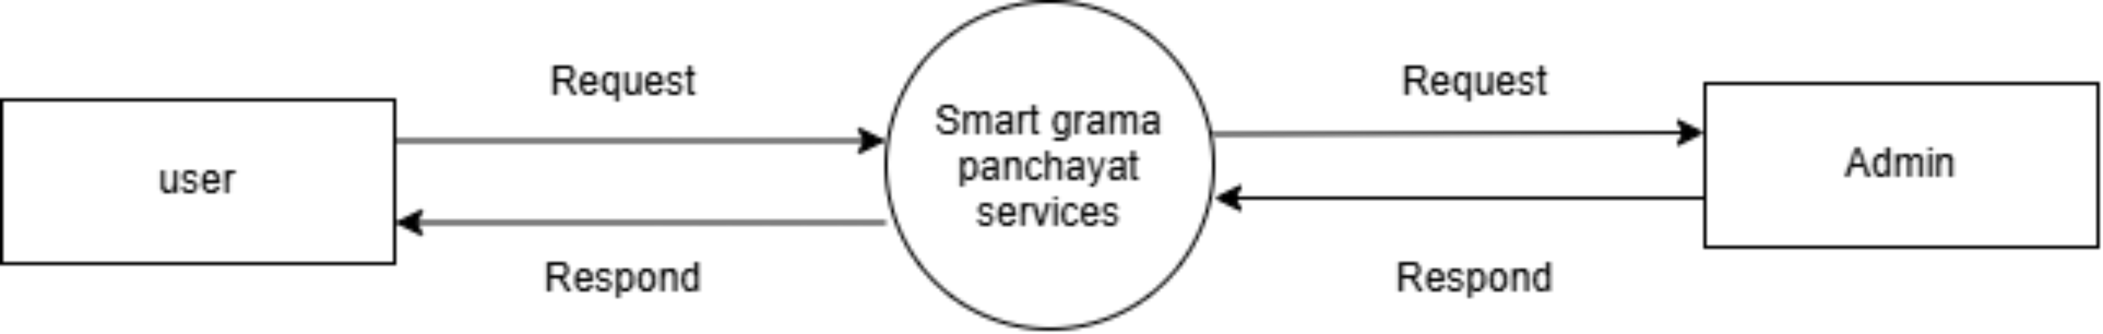
Figure 4.1 Data Flow Diagram Level 0
At Level 0, the portal is treated as a single process boundary. Citizens send service requests and receive application status, certificates, notices and alerts, while administrators submit management decisions and retrieve operational information. This context view establishes the external actors before the detailed Level 1 decomposition.

4.1.1 DFD LEVEL 1 - CITIZEN
9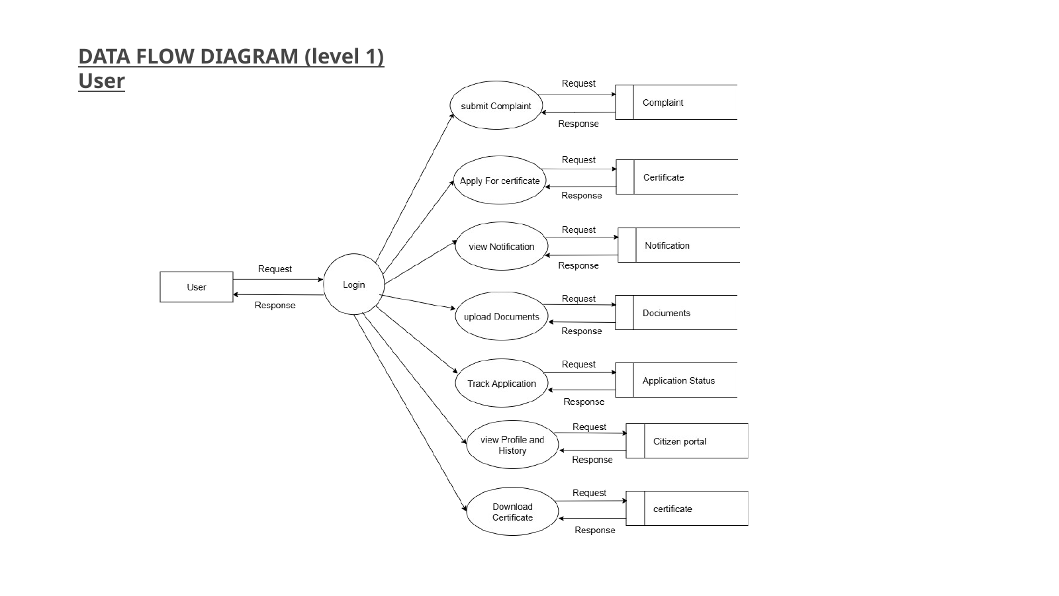
Figure 4.2 Data Flow Diagram Level 1 - Citizen
The citizen authenticates and interacts with certificate applications, complaints, notifications, document upload, application tracking, profile/history and certificate download. Each process reads or writes the corresponding application data while authorization limits the citizen to personal records.
The citizen-side decomposition shows that authentication is the entry point to several independent services. Complaint submission, certificate application, document upload, notifications, application tracking, profile/history and certificate download interact with their corresponding data stores. The model reflects the implemented ownership rule that a citizen can access only records associated with the authenticated account.
4.1.2 DFD LEVEL 1 - ADMIN
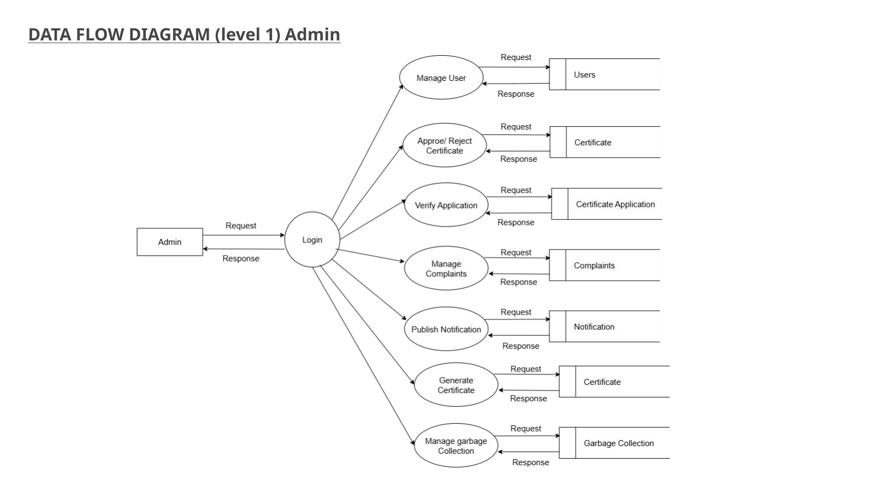
Figure 4.3 Data Flow Diagram Level 1 - Admin
The administrator manages users, verifies and decides certificate applications, manages complaints, publishes notifications, generates certificates and coordinates waste collection. The implemented code further adds official announcements, reports and safety alerts.
The administrative DFD expands the official workflow into user management, application verification, certificate decision and generation, complaint handling, notification publishing and waste-management coordination. These processes represent controlled operations rather than unrestricted database access; the backend validates role permissions and allowed state transitions before changes are stored.
4.1.3 DFD LEVEL 1 - WASTE COLLECTOR
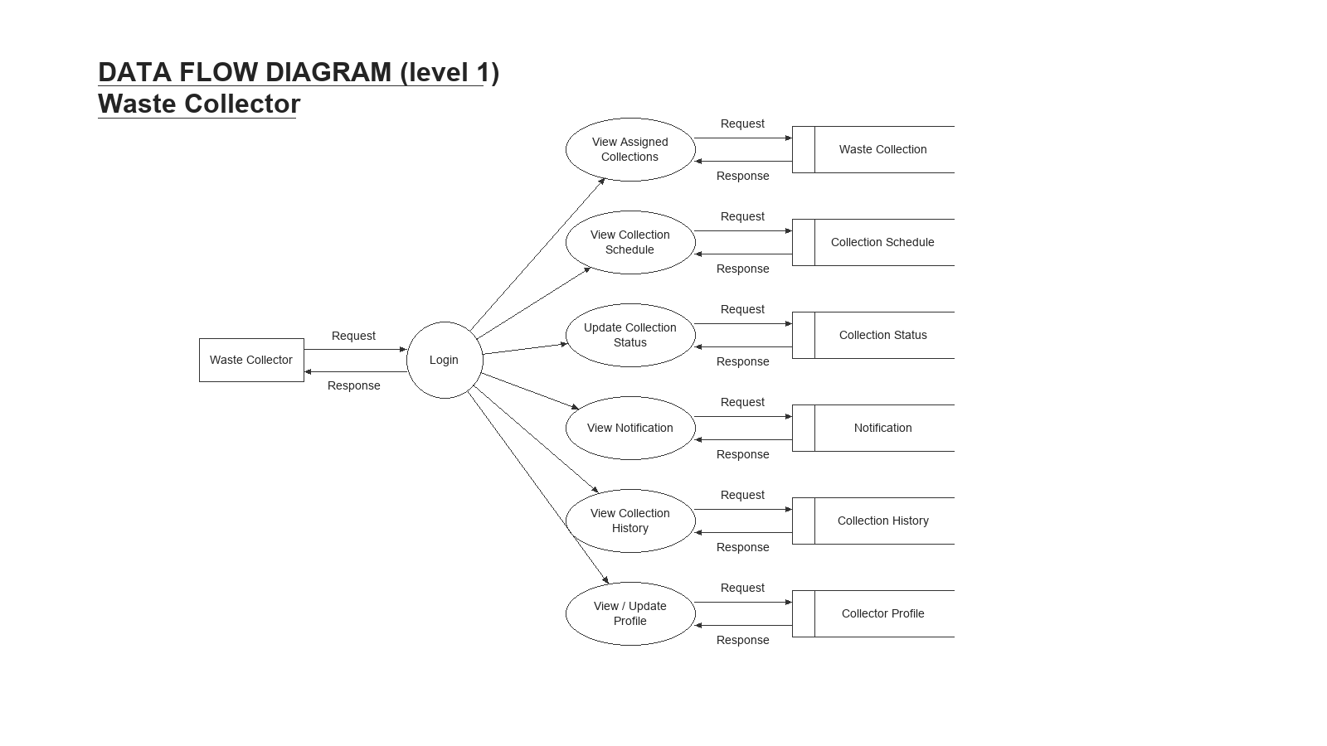
Figure 4.4 Data Flow Diagram Level 1 - Waste Collector
The waste collector logs in to view assigned collections, confirm the collection schedule, update collection status, receive notifications, review collection history and maintain the collector profile. The diagram shows how these field operations exchange data with the corresponding waste collection, schedule, status, notification, history and profile records.

4.2 USE CASE DIAGRAM
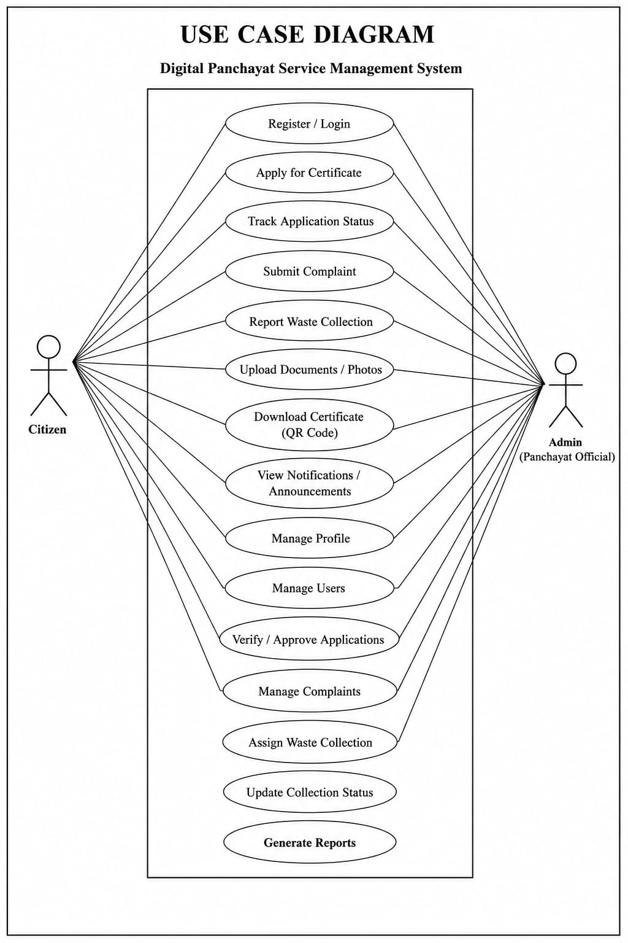
Figure 4.5 Use Case Diagram
The use case diagram summarizes citizen and Panchayat official interactions. Shared operations include authentication and viewing system information, while administrative use cases introduce approval, complaint management, assignment and reporting responsibilities.
The use-case view complements the DFD by emphasizing responsibility rather than data movement. Citizen actions focus on requesting and tracking services, official actions focus on review and coordination, and waste-collector actions focus on assigned field work. Common functions such as login, profile management and notifications connect the roles without giving every actor the same permissions.

4.3 CLASS DIAGRAM
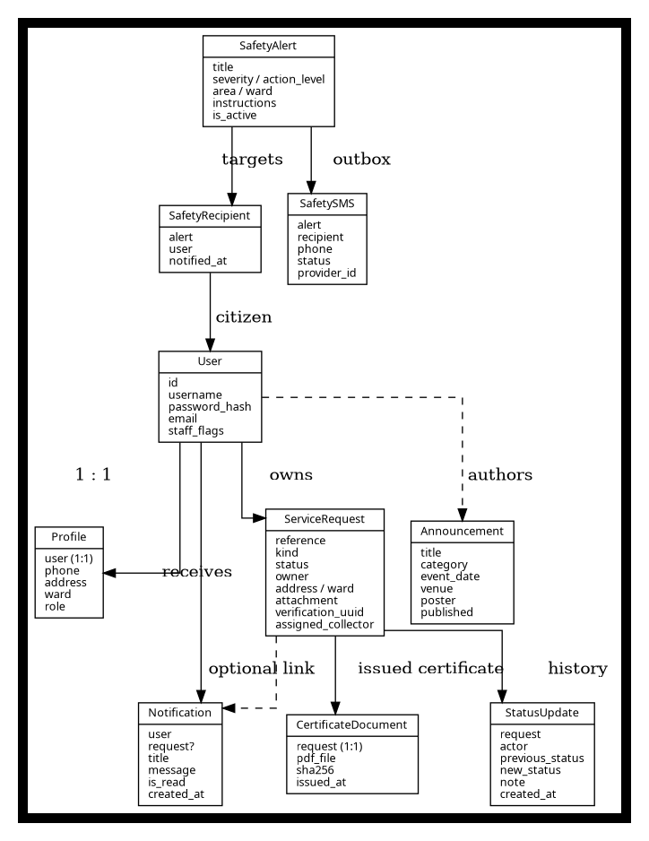
Figure 4.6 Class Diagram
The class diagram models application users and service entities. In the implemented project, the central entities are Profile, ServiceRequest, StatusUpdate, Notification, Announcement, CertificateDocument, SafetyAlert, SafetyRecipient and SafetySMS. Django’s built-in User model supplies authentication and staff privileges.
The class relationships show how persistent information is separated by responsibility. ServiceRequest stores the current request state, StatusUpdate preserves history, Notification records user messages, CertificateDocument stores finalized certificate output, and the safety-related entities preserve alert recipients and optional SMS-delivery records. This separation supports traceability and reduces the need to overwrite historical information.

4.4 STATE DIAGRAM
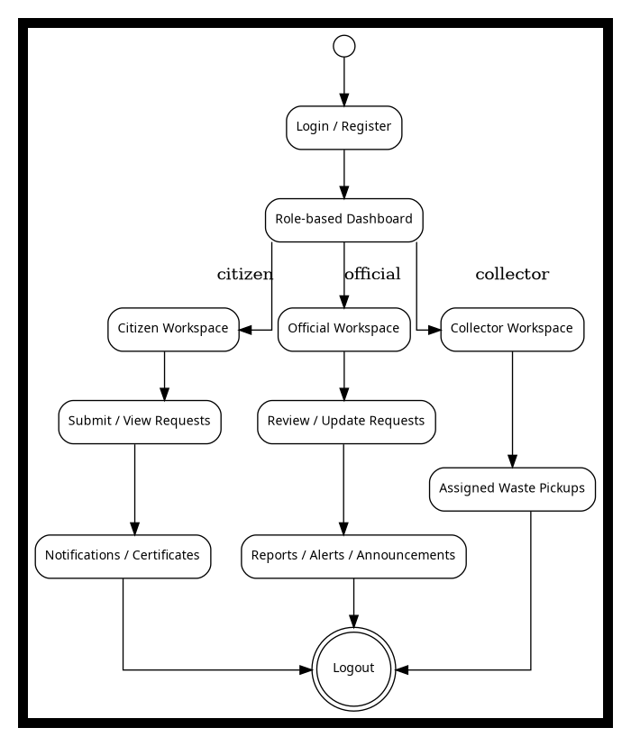
Figure 4.7 State Diagram
The state diagram represents the user journey and service interactions. At the backend, individual service requests also follow controlled status machines. Certificates progress toward approval or rejection, complaints toward resolution and waste requests toward scheduling and collection.

4.5 ACTIVITY DIAGRAM
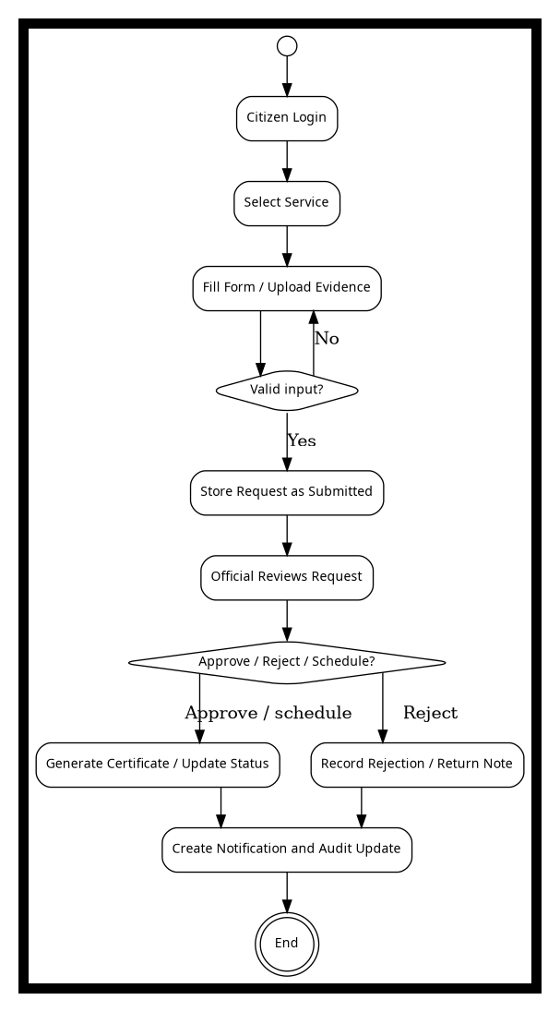
Figure 4.8 Activity Diagram
The activity diagram shows a typical interaction beginning with login, service selection and form submission, followed by administrator review and an updated result. This separation between citizen submission and official decision is implemented through role-aware views and a service transition layer.

4.6 SEQUENCE DIAGRAM
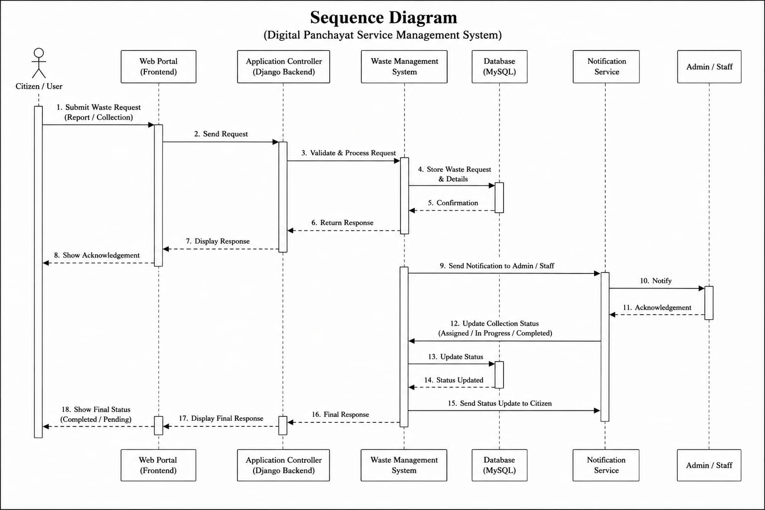
Figure 4.9 Sequence Diagram
The sequence diagram traces interaction among the citizen, web portal, application controller, workflow manager, database, notification service and administrator. The implementation follows a comparable pattern: views receive a request, forms validate input, service functions update the database and notifications are created after relevant workflow events.

4.7 DIAGRAM INTERPRETATION
Together, the diagrams show that the project is not a single CRUD form. It is a multi-role information system where service requests pass through defined processes and where notifications, documents, verification and assignments are related to those processes.
The DFDs emphasize data movement, the use case diagram emphasizes actor responsibilities, the class diagram emphasizes structure, the state/activity diagrams emphasize workflow and the sequence diagram emphasizes runtime interaction. These views complement one another and were used to guide the implementation.
The diagrams also demonstrate how responsibility moves across system boundaries. The DFDs show information entering through citizen or administrative actions and being stored as service records, notifications and certificate data. The use case model shows which actor is allowed to initiate each operation, while the sequence model shows when those operations occur relative to database updates and notifications. Reading the diagrams together therefore provides a more complete understanding than any single diagram alone.
The class and state diagrams support implementation decisions. Entity relationships indicate where ownership, assignment and history must be stored, and the state model identifies the controlled lifecycle that prevents arbitrary status changes. This correspondence between design and code is important in the project because workflow validation is implemented in backend services rather than only represented visually in the interface.
The activity diagram focuses on the citizen-to-official processing path and highlights decision points such as approval, rejection, scheduling and completion. In the implemented system, these decisions are captured as persisted status changes, which allows the same logical flow to be reconstructed later from the audit history. The diagrams are therefore used as design documentation for the working application rather than as independent illustrations.

CHAPTER 5
METHODOLOGY

5.1 DEVELOPMENT METHODOLOGY
The Waterfall-oriented approach was selected because the mini project had a defined review structure and a stable set of core deliverables. Requirement analysis identified actors and services first; design work then produced data-flow, UML and architecture models; implementation translated those models into Django applications and templates; finally, test cases were used to verify workflow and security behavior before documentation.
Although development was structured by phases, feedback from implementation was used to refine the design. For example, certificate verification was narrowed from a broad “secure certificate” concept to a concrete QR token plus stored PDF fingerprint, and safety communication was represented through an alert/recipient/outbox model. These refinements keep the report consistent with what the supplied source code actually implements.
The project follows a structured Waterfall-oriented methodology for academic development. Requirements were first defined from the service problem, followed by system and database design, interface planning, implementation, testing and final documentation. Although software maintenance is iterative in practice, the Waterfall structure provides clear deliverables for a mini-project review process.
The main phases are requirement analysis, system design, database design, user-interface design, development, testing and deployment preparation. Each phase produces information used by the next phase: requirements become models and routes; models become forms and services; and implementation becomes test cases and documentation.

5.2 MODULE DESCRIPTIONS
MODULE | RESPONSIBILITIES
Citizen Account | Registration, login, profile, ward/contact information and authenticated dashboard.
Certificate Services | Application data, document upload, official review, approval/rejection, fixed PDF issue and QR verification.
Complaint Management | Citizen issue reporting, category/severity, official review, progress and resolution.
Waste Collection | Citizen pickup request, preferred date, official scheduling, collector assignment and collection completion.
Notifications | Submission/status messages and unread count for the signed-in account.
Announcements | Public notice board with category, event information and poster support.
Reports | Administrative counts and CSV request export.
Safety Alerts | Official warning issuance, ward targeting, acknowledgement, closure and optional SMS outbox.
Multilingual Interface | English / Malayalam switch for citizens and collectors, persistent profile preference, server-side UI translation and browser-side translated labels.

5.2.1 Citizen Module
The citizen module is the main public-facing component. New users create an account using the registration form and receive a profile record. After login, the dashboard provides links to create and review service requests. Citizens can update their contact profile, read notifications and access published notices.
Request visibility is owner-based. A citizen cannot open another citizen’s request by altering the URL. The same access rule applies to supporting-document downloads. This makes authorization part of the server-side design instead of relying only on hidden navigation links.
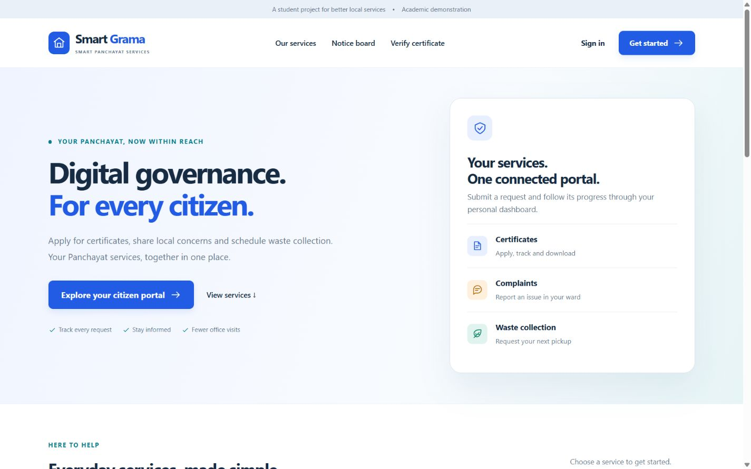
Figure 5.1 Citizen portal screens (Home page and citizen dashboard)
The screenshots highlight the public landing page and the authenticated citizen dashboard. Together they demonstrate how the system moves from general service visibility to a personalized workspace for requests, certificates, notifications and community updates.

5.2.2 Authentication and Login
Authentication uses Django’s standard login system. Password storage is delegated to Django’s password hashing framework. CSRF middleware protects state-changing form submissions. Public registration does not expose staff or role-escalation fields.
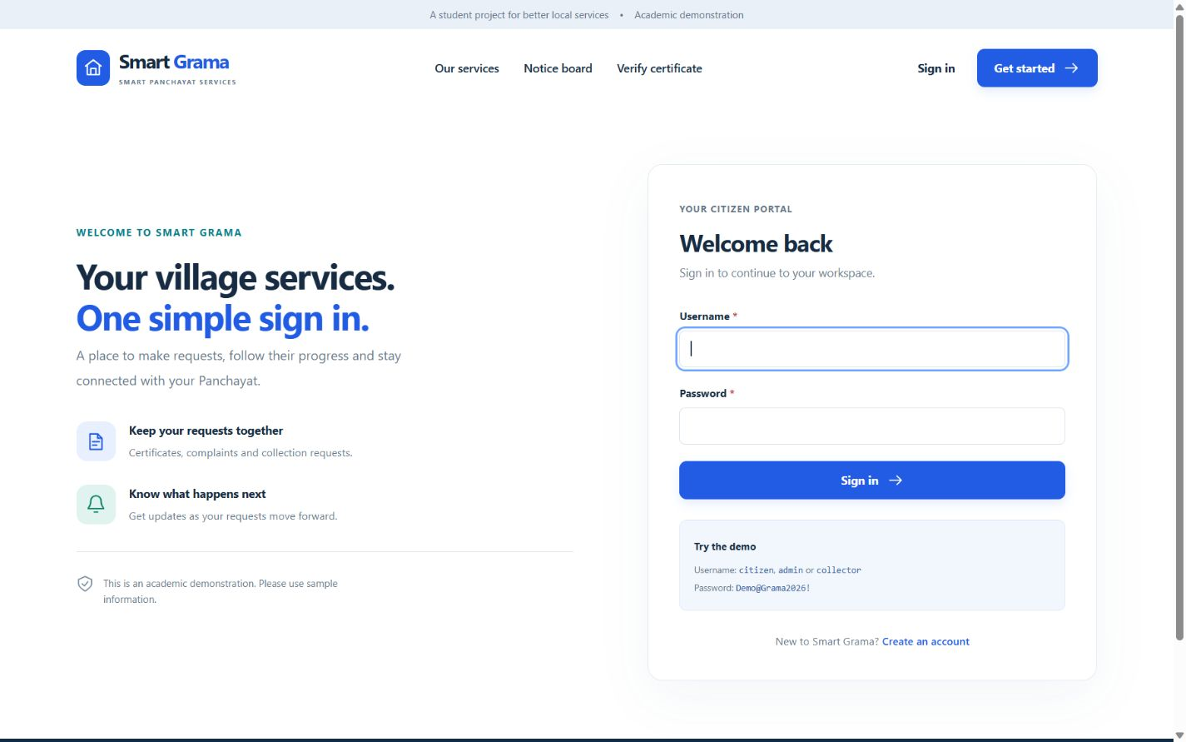
Figure 5.2 Authentication screens (Login and registration)
These interfaces illustrate the controlled entry point to the system. Registration captures the citizen profile used later in request workflows, while the login page authenticates returning users and routes them to the correct role-based workspace.

5.2.3 Certificate Module
The certificate module supports birth, death, residence, property ownership and general academic certificate categories. Forms collect service-specific information such as the person named on the certificate, event date, place and relationship where applicable. Supporting documents are validated for file type and size before being stored with randomized names.
When an official approves a certificate, the issue timestamp is recorded and a fixed PDF is generated and stored. A SHA-256 fingerprint and an issue snapshot are stored with the PDF. Later downloads return the same issued bytes rather than regenerating the document from potentially changed profile information. This improves integrity of the issued record.
The module separates application data from the final issued document. Supporting files remain private and are available only to authorized users. Approval freezes the relevant certificate state and generates an immutable stored PDF, while revocation changes public validity without silently replacing the original issued bytes.
Certificate applications use a common request model while storing certificate-specific information such as certificate type, subject details, event date or place and supporting evidence. This design avoids creating a separate application table for every certificate category while still allowing the form to present fields conditionally. The current demonstration includes birth, death, residence, property ownership and general certificate types and can be extended by adding new choices and validation rules.
Approval triggers a separate document-generation stage. The issued PDF is treated as a finalized output rather than a live screen print. A stored certificate record contains the generated bytes and a cryptographic hash so that later verification compares against the exact approved document. This separation prevents ordinary edits to the underlying application from silently changing a certificate that has already been issued.
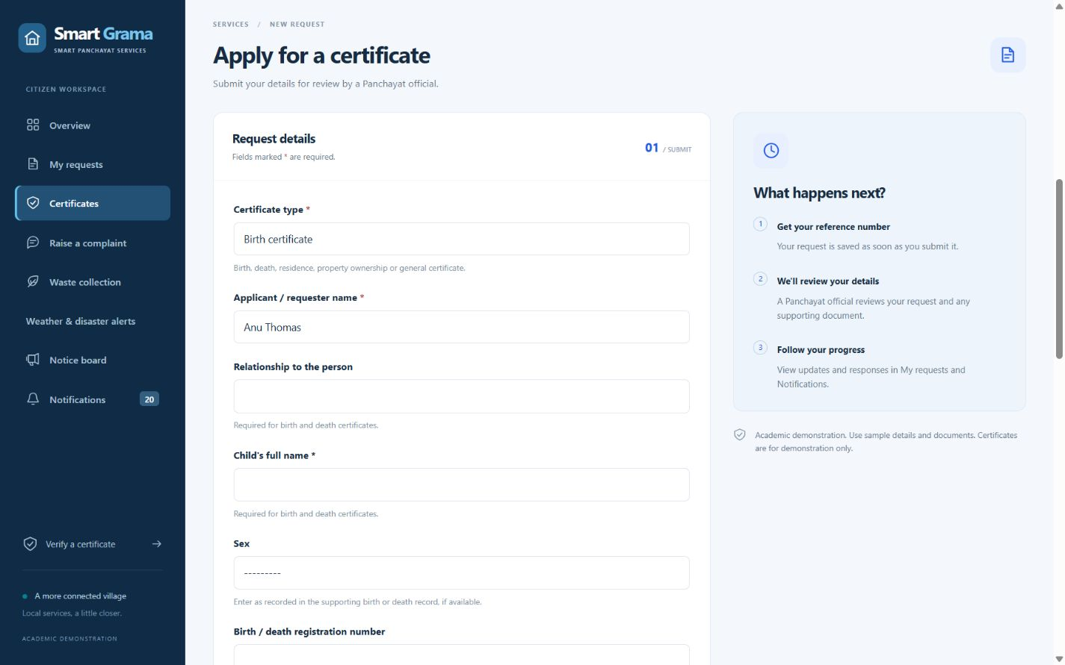
Figure 5.3 Certificate service screens
The certificate module collects application data and later presents the stored details in a structured view for review. The screenshots show how service-specific fields and supporting information are organized before approval and document generation.

5.2.4 QR Verification Module
Each service request receives a UUID verification token. For an approved certificate, the generated QR code embeds a verification path containing this token. Anyone with the token can open a limited public page that checks the current database status and displays non-sensitive verification details such as reference, certificate type, issue date and applicant initials.
The verification page can also compare an uploaded PDF against the SHA-256 fingerprint of the stored issued PDF. A matching fingerprint indicates that the uploaded file is byte-for-byte identical to the stored original. The design explicitly does not claim that a QR code or hash is equivalent to a government digital signature.
The QR workflow is intentionally privacy-limited. Scanning the code opens a public verification route identified by an unguessable UUID, but the page does not expose private supporting documents, full addresses or phone numbers. This allows authenticity checking without turning the verification endpoint into a source of citizen data.
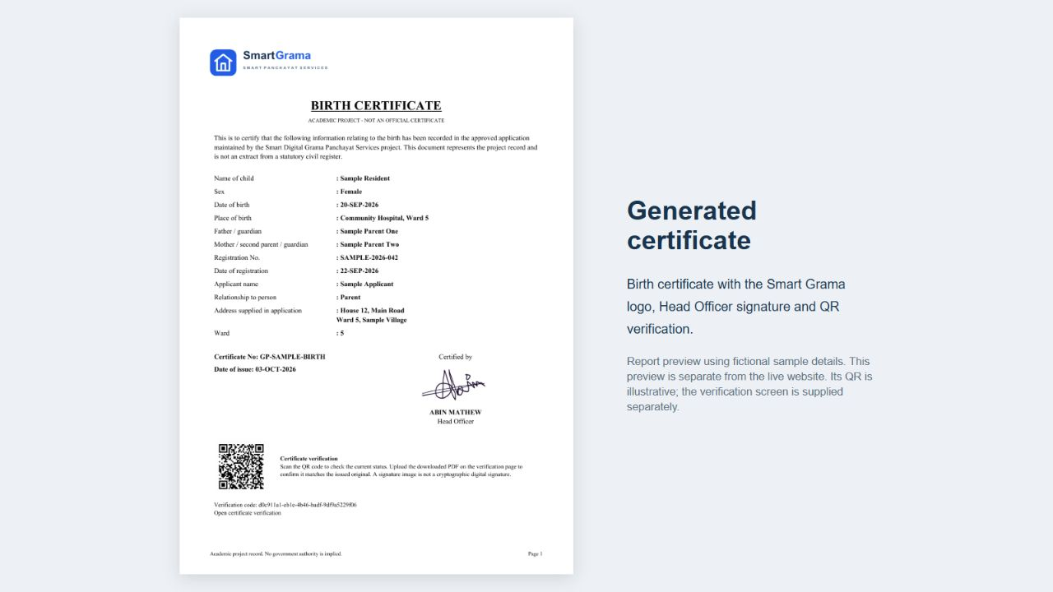
Figure 5.4 Certificate output and verification screens
The generated certificate and public verification page demonstrate the trust layer built into the project. The certificate carries a QR-linked verification path, while the verification screen exposes only limited public information needed to confirm validity.

5.2.5 Complaint Module
Citizens can submit civic complaints with a title, description, location information, category and severity. Officials review the complaint and may move it through under-review, in-progress and resolved states. Rejection is also supported with an explanatory note.
Because every transition creates a status update, the citizen can see a chronological record rather than only the final result. This is important for service transparency and for explaining how long a complaint remained in each stage.
Complaint categories help officials filter similar issues and distinguish routine civic problems from safety/disaster reporting. Status history and notes provide the citizen with a visible progression from submission to resolution and give officials a record of the action already taken.
Complaint processing is designed around visibility and progressive status updates. The citizen supplies a category, location and detailed description and may attach evidence where appropriate. Officials can then review the request, record a status change and add a note that becomes part of the request history. This structure supports accountability because the citizen can distinguish between submission, active handling and final resolution instead of receiving only a generic acknowledgement.
The complaint module also demonstrates reuse of the common workflow. Although complaint data differs from certificate and waste data, the same underlying concepts of reference number, ownership, status history and notification are retained. Reusing these elements simplifies reporting and keeps the user experience consistent across service categories.

5.2.6 Waste Collection Module
The waste collection module lets a citizen request a collection and provide a preferred date. The allowed preference range is restricted to today through ninety days ahead. An official can schedule a date and assign an active collector. The collector sees assigned waste requests and can mark a scheduled request as collected.
The design stores preferred date and scheduled date separately. This preserves the original citizen preference while allowing the Panchayat to confirm an operational date. Assignment and completion are controlled by role and status checks.
The waste workflow introduces assignment because completion is performed by collection staff rather than by the citizen or the reviewing official. The system preserves the citizen’s preferred date separately from the confirmed schedule so that operational changes do not erase the original request.
Waste collection requires coordination between a citizen, an official and field staff. The citizen indicates the waste category, location and preferred collection date. An official reviews the request, confirms a feasible schedule and assigns a collector where required. The collector workspace presents assigned tasks and permits completion to be recorded. Each step remains connected to the original request so the citizen can follow progress without contacting the office separately.
The implementation keeps the requested date distinct from the confirmed schedule. This is significant because a citizen preference should not be overwritten when the administration selects another operational date. Preserving both values supports clearer communication and provides a better audit trail for future extensions such as route planning, capacity management or missed-collection analysis.
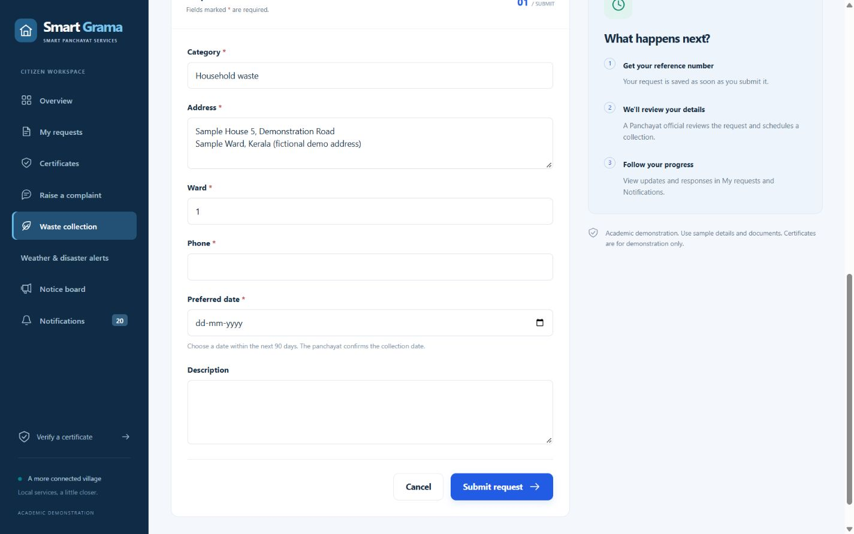
Figure 5.5 Complaint and waste collection screens
These screenshots show two high-frequency citizen service interactions beyond certificates. The complaint form captures civic issues for administrative follow-up, while the waste-collection form supports service scheduling and operational assignment.

5.2.7 Announcement, Notification and Report Modules
Announcements provide a digital notice board with categories, event dates, venue information and optional poster images. Draft notices and poster access are restricted to officials, while published notices are visible publicly.
Notifications are created in the database after relevant events such as request submission and status changes. The interface polls the unread count while visible. Administrative reports summarize stored request data and permit CSV export; cells that could trigger spreadsheet formulas are escaped before export.
Administrative reports summarize request activity and can be exported in CSV format for further analysis. The notification model provides user-specific messages, while announcements are public notice-board items with category, venue, event date and optional poster. Keeping these concepts separate prevents a public announcement from being confused with a private service update.
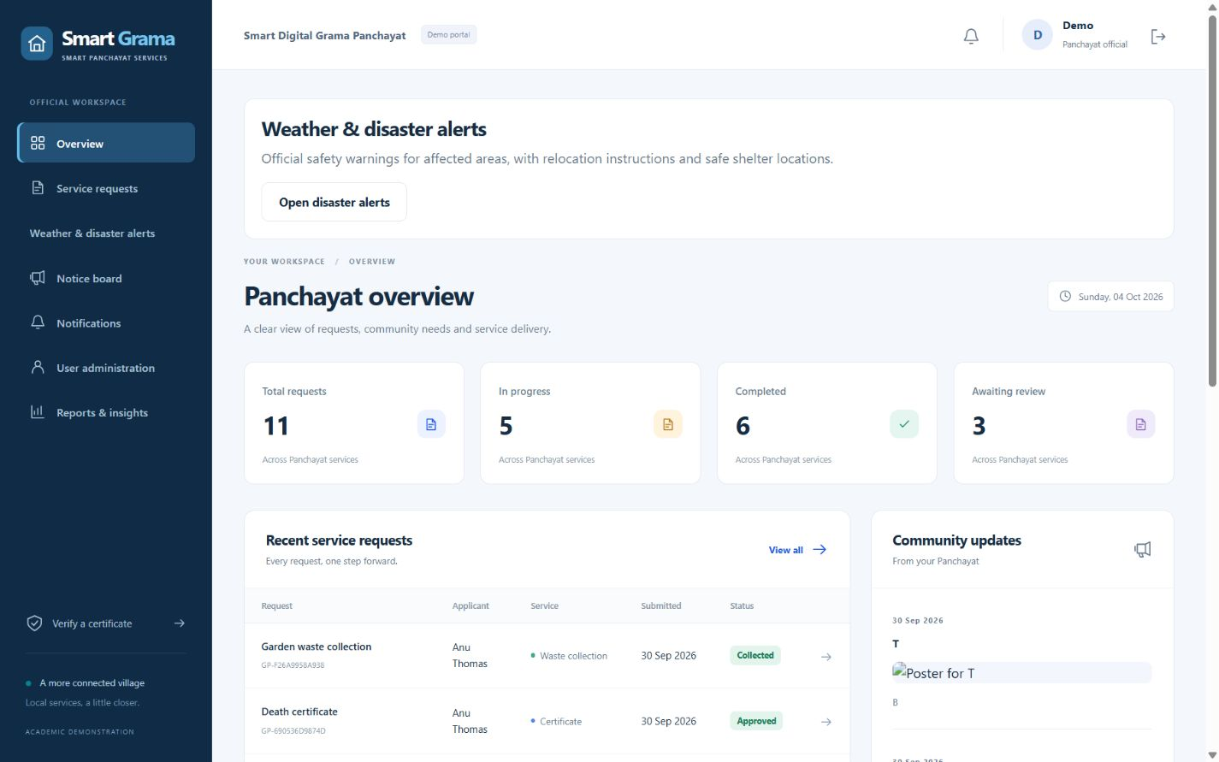
Figure 5.6 Administrative information screens
The administrative workspace combines decision support and communication. The screenshots show the official dashboard, analytics reports, public notice board and notification center, illustrating how the system supports both operational monitoring and citizen information dissemination.

5.2.8 Safety and Disaster Alert Module
Authorized officials can issue a safety alert containing an action level, affected area, optional ward, safe place, instructions and contact information. Issuance snapshots the target citizen accounts into recipient records and creates linked notifications. Citizens see only the alerts addressed to them and may acknowledge that they have read an alert.
Closing an alert requires an explanation and records the closing official and timestamp. An optional SafetySMS outbox stores the intended phone number and message text so that a separate worker can submit messages to a configured provider. Provider delivery is not required for the website alert to function.
Recipient records snapshot which citizens were targeted when an alert was issued. This is important because later changes to a profile or ward should not alter the historical meaning of an earlier alert. Optional SMS records also track delivery state separately from the alert itself so that communication failures can be reviewed without changing the official alert record.
The safety module expands the portal from routine services to urgent communication. An authorized official can create an alert with severity/action level, affected area, optional ward, instructions and safe-place information. Target recipients are determined when the alert is issued so the system retains evidence of who was included at that time. Citizens then see the alert prominently within the portal and receive a corresponding notification record.
Optional SMS delivery is implemented through an outbox pattern rather than by sending directly from the page request. Pending messages are processed separately and move through delivery states such as submitted, delivered or failed. This design is more reliable for external messaging because a temporary provider failure does not need to roll back the creation of the safety alert itself. In the academic build, provider configuration is optional and can remain in simulated mode.
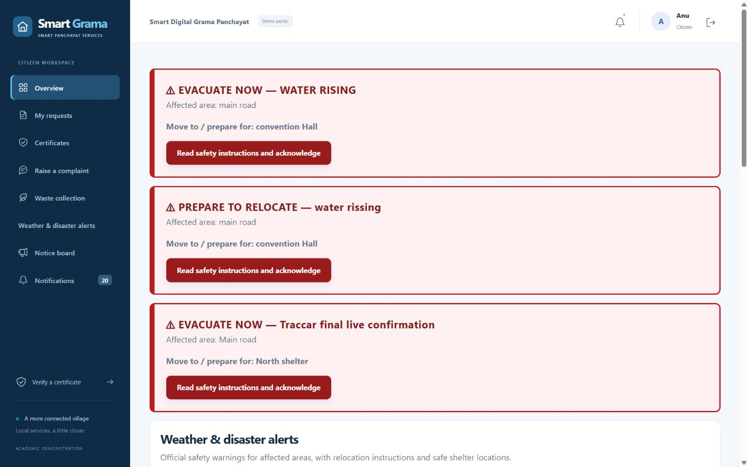
Figure 5.7 Safety and disaster alert screens

The safety-alert module extends the project beyond routine service management. The screenshots capture active warnings for citizens, the administrative alert list and the create-alert interface used to issue targeted emergency instructions.

5.2.9 MULTILINGUAL ENGLISH–MALAYALAM INTERFACE
The updated project includes a bilingual interface option designed for citizen and waste-collector accounts. A language switch labelled English / മലയാളം is displayed in the authenticated top bar for these roles. Selecting Malayalam changes the interface language for navigation, dashboards, service-request forms, status labels, certificate-verification messages, notifications and other translated portal text. Selecting English returns the same interface to the original English labels.
The preference is persistent rather than temporary. The Profile model stores a two-character language value with English as the default and Malayalam as the alternative. PortalLanguageMiddleware reads this value for each authenticated citizen or collector and activates the appropriate language context. Staff and superuser accounts are intentionally kept in English and do not receive the language switch, which avoids ambiguity in official administrative terminology.
Translation is implemented locally in the application. Malayalam text is maintained in portal/malayalam.json; the portal_language template tag translates server-rendered labels, and static/js/language.js provides corresponding browser-side translations. The translation mechanism targets interface text only. Names, addresses, complaint descriptions and other content entered by users remain exactly as stored, preventing accidental modification of citizen records.
The language-change endpoint accepts only en or ml through a POST request. It also validates the requested return URL and falls back to the dashboard when the destination is unsafe. Automated tests verify persistence after logout/login, switching back to English, collector access, staff restrictions, invalid-language rejection, CSRF protection and Malayalam rendering across key citizen pages and service forms.
Visual verification of the updated interface confirms that the language switch appears in the authenticated top navigation and that Malayalam labels are rendered on the citizen dashboard, birth-certificate application, complaint form and digital notice board. The same pages can be returned to English through the switch without altering the underlying stored request data.

5.3 ALGORITHMS AND BUSINESS RULES

5.3.1 Service Request Transition Algorithm
- Receive requested target status and current authenticated user.
- Lock/read the target service request inside a database transaction.
- Check that the user role is permitted to perform the action.
- Check that the target status is allowed from the current status for the request kind.
- Validate action-specific data such as rejection note, collector and scheduled date.
- Update the ServiceRequest status and related fields.
- Create a StatusUpdate record containing actor, old status, new status, note and timestamp.
- Create recipient notification(s) as needed.
- Commit the transaction; if any rule fails, rollback and return a validation error.

5.3.2 Certificate Fingerprint Verification Algorithm
- Read the uploaded candidate PDF in memory without permanently storing it.
- Compute SHA-256 digest of the uploaded bytes.
- Retrieve the stored issued CertificateDocument using the verification token.
- Compare the candidate digest with the stored original digest using exact equality.
- Report match only if the certificate remains valid and the fingerprint is identical.

5.4 ARCHITECTURE
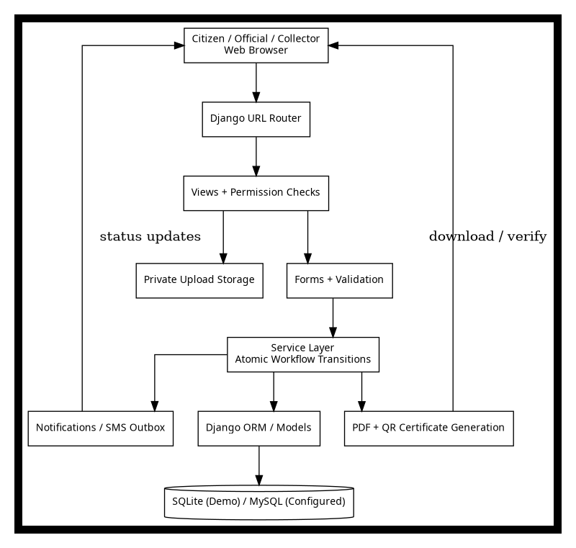
Figure 5.8 System Architecture
The application follows Django’s Model-View-Template pattern. Models define persistent data and relationships; forms validate user input; views implement HTTP request handling and role checks; services centralize workflow transitions; templates render the interface; and static CSS/JavaScript provides responsive styling and browser-side enhancements.
The architecture diagram in the review material includes security, audit logging, QR tracking and a secure database concept. The implemented source code provides hashed passwords, access-controlled uploads, audit histories and QR verification. It does not implement AES encryption at rest, and this limitation is explicitly documented in the project source.
At the presentation layer, server-rendered templates provide the public pages, citizen portal and staff workspaces. The application layer contains views, forms and reusable service functions. The persistence layer is handled through Django ORM models, allowing the same application logic to use SQLite for demonstration or a configured MySQL database. Static JavaScript is limited to interface enhancements such as notification polling and QR scanning, keeping the core workflow functional through standard HTTP requests.
Cross-cutting concerns include authentication, authorization, validation, file privacy, logging through status-history records and generation of verifiable certificate outputs. These concerns are deliberately placed close to the backend rules rather than relying only on frontend visibility. The architecture therefore emphasizes correctness and access control at the server, which is important when records contain personal information or administrative decisions.

5.5 DATABASE DESIGN
The central ServiceRequest table uses a request kind to distinguish certificate, complaint, disaster and waste workflows while keeping common fields such as owner, reference, status, address, ward, phone and timestamps in one place. This reduces duplication and allows request lists, filters and reports to operate consistently across service categories. Optional fields hold data that is meaningful only for particular request types, while form validation controls when those fields are required.
Related tables preserve information that should not be overwritten. StatusUpdate stores the previous and new state, actor, note and time; Notification stores messages delivered to individual users; CertificateDocument stores the finalized issued PDF and its fingerprint; Announcement stores notice-board content; and safety-related records store alert and delivery information. Foreign-key relationships connect these records back to the relevant request or user, creating a relational history that supports both operational views and later reporting.
ENTITY | IMPORTANT FIELDS / PURPOSE
Profile | User link, language preference (English/Malayalam), phone, address, ward, citizen/collector role.
ServiceRequest | Owner, reference, kind, status, service-specific fields, assignment, attachment, verification token, timestamps.
StatusUpdate | Request, actor, from/to status, note, time.
Notification | Recipient, request/alert links, title, message, read flag, time.
Announcement | Category, date, venue, poster, title, body, published state, author.
CertificateDocument | Frozen PDF bytes, SHA-256, issue snapshot, creation time.
SafetyAlert | Action, area, ward, safe place, instructions, contact, issuer, closure audit.
SafetyRecipient | Alert, targeted user, acknowledgement time.
SafetySMS | Alert/user/event, phone, body, delivery status, provider id, attempts and retry data.

5.6 CASE STUDY
Consider a citizen who needs a residence certificate and also wants to report an uncollected waste item. The citizen registers, completes the profile and submits a residence-certificate request with the required contact/address information and supporting document. The system immediately assigns a unique reference and shows the request as Submitted.
An official reviews the certificate. If the evidence is acceptable, the official approves the request. The system records the status update, sets the issue time, generates the fixed PDF and creates a notification. The citizen downloads the certificate. A third party scans the QR code and opens the public verification page, which confirms that the token refers to a currently approved record.
For the waste request, the citizen selects a preferred collection date. An official confirms a feasible date and assigns a collector. The collector sees the assignment, performs the pickup and marks the request Collected. The citizen’s history shows submission, scheduling and collection as separate events. The case study demonstrates coordinated roles and traceability across two service types.

5.6.1 CASE STUDY OUTCOME AND OBSERVATIONS
This case study demonstrates that the same citizen account can move between independent Panchayat services without losing a consistent interaction pattern. Each request receives its own reference and lifecycle, yet authentication, ownership checks, notifications and history are reused. From the citizen’s perspective, this produces a single portal experience; from the implementation perspective, it avoids duplicating security and tracking logic for every module.
The scenario also illustrates the value of role separation. The citizen supplies information and follows progress, the authorized official performs the administrative decision, and the waste collector sees only the collection work assigned to that role. Certificate verification is deliberately separated from the private application record so a public verifier can confirm validity without gaining access to supporting documents or full contact details. These observations support the project objective of improving transparency while preserving controlled access to sensitive information.

CHAPTER 6
IMPLEMENTATION DETAILS

6.1 IMPLEMENTATION PROCEDURES
Implementation began with environment configuration and database migrations, followed by the creation of the shared service-request model and role-aware profile model. Forms and views were then added for registration, request submission and dashboards. The workflow service layer was introduced before the administrative screens so that every later interface would use the same transition rules rather than duplicating status logic.
Document generation and safety-alert functionality were integrated after the basic request lifecycle was stable. The testing stage then concentrated on ownership checks, forbidden transitions, private-file access, certificate immutability and revocation, CSV safety and alert behavior. This sequence reduced the risk that user-interface changes would hide weaknesses in backend authorization.
Implementation began by configuring the Django project and defining the data model required for profiles, service requests, request updates, notifications, announcements, certificate documents and safety alerts. Database migrations were then created so that the model structure could be reproduced consistently. After the schema was stable, forms and views were implemented incrementally for registration, citizen requests and administrative processing.
The next stage connected business rules to the interface. Shared transition functions were introduced so that request-state validation, update logging and notification creation occur together. Certificate PDF generation and verification were integrated after the approval workflow was working, followed by reporting, announcement and safety-alert features. This sequence reduced dependency problems because later modules could rely on previously tested authentication and request-management components.
LAYER | TECHNOLOGY / IMPLEMENTATION
Programming language | Python
Web framework | Django 5.2 series
Frontend | HTML5, CSS3, JavaScript and Bootstrap-compatible styling
Data access | Django ORM and migrations
Database | SQLite validated locally; optional MySQL configuration supplied
PDF generation | ReportLab
QR generation | qrcode with Pillow support
QR scanning | Locally bundled jsQR
Configuration | python-dotenv / environment variables
Deployment helper | Waitress
Version control / tools | Git, GitHub, VS Code, diagram/wireframe tools
Localization | Profile language preference, PortalLanguageMiddleware, custom template filter, local Malayalam JSON catalogue and JavaScript translation helper.

6.1.1 Project Structure
- config/settings.py - Django project settings and environment-driven configuration.
- config/urls.py - root URL configuration.
- portal/models.py - service, notification, certificate and safety entities.
- portal/forms.py - registration, profile, request and admin forms.
- portal/views.py - page handlers, role checks, dashboards, verification and reporting.
- portal/services.py - request state-transition logic and shared business rules.
- portal/certificates.py - PDF and QR certificate helpers.
- portal/validators.py - attachment, poster and phone validation.
- portal/sms.py - SMS outbox/provider adapter logic.
- portal/tests*.py - automated functional, security, disaster-alert and SMS tests.
- templates/ - shared layout, registration pages and portal screens.
- static/ - CSS, JavaScript, QR scanner and locally bundled libraries.

6.1.2 Authentication and Authorization Implementation
Django’s built-in authentication system is used for credentials and sessions. A one-to-one Profile model stores citizen-specific information and the optional collector role. Official access is represented by active staff status. Public forms do not permit a user to set staff status or change themselves into an official.
Views use ownership-filtered query patterns for citizen records and assignment-filtered patterns for collectors. Administrative views require staff authorization. This pattern is repeated for request details, attachments, certificate downloads, reports, notice editing and safety-alert operations.

6.1.3 File Upload and Certificate Implementation
Attachments receive randomized filenames. The project accepts PDF, PNG and JPEG files up to 5 MB. Image data is validated using Pillow, and PDF uploads are checked for a PDF header. These checks reduce accidental or misleading uploads but are not a substitute for malware scanning.
On approval, the certificate helper creates the PDF once and stores the bytes in CertificateDocument together with a SHA-256 digest and snapshot. This is a deliberate design choice: later profile changes cannot silently alter the already issued PDF.

6.1.4 Safety Alert and SMS Implementation
Safety alert issuance is implemented as an official-only operation. The application selects active citizen accounts by ward or across all wards, creates SafetyRecipient rows, creates in-app notifications and queues optional SafetySMS records inside the same logical operation. This preserves a snapshot of who was targeted at issuance time.
A separate management command processes pending SMS outbox records. The adapter can run in disabled/simulated mode or connect to a configured provider. Delivery states are tracked separately from web notifications so a provider failure does not remove the in-app warning.

6.1.5 English–Malayalam Translation Implementation
The localization feature is implemented without introducing an external translation API. The Profile model stores language="en" or language="ml". A dedicated language migration adds this field to existing profiles with English as the default, so older accounts remain compatible after migration.
A role-scoped middleware activates the stored preference only for authenticated non-staff users. The set-language view is login-protected, accepts POST only, rejects unsupported language codes, and prevents Panchayat staff or superusers from switching the administrative workspace. The view also validates the next URL before redirecting, reducing open-redirect risk.
For server-rendered pages, a custom template filter looks up English interface strings in the Malayalam JSON catalogue whenever the current language is ml. JavaScript uses a generated local translation map for dynamic labels and QR-verification messages. Because the translation catalogue is bundled with the project, the bilingual interface works without calling a third-party translation service and does not transmit citizen text outside the application.

6.2 TESTING METHODS AND RESULTS
The supplied project documentation records automated and manual validation on a local workspace using Python 3.12.14 and Django 5.2.17. The source project reports that manage.py check completed without issues, migrations were applied successfully using SQLite and the portal test suite passed 68 tests. A live MySQL integration test was not performed in that validation environment.
Testing covers core workflows, access control, invalid transitions, certificate immutability, file privacy, revocation, form validation, notifications, CSV export protection, safety alerts, QR scanner handling and SMS outbox behavior. The test suite is divided across the main portal tests and additional files for new functionality.
Testing combines automated regression checks with manual browser verification. Automated tests exercise form validation, permission boundaries, allowed and forbidden transitions, certificate generation, revocation behavior, private-file access and selected security conditions. Manual tests complement these checks by confirming that pages remain understandable, navigation is consistent and complete workflows can be demonstrated using citizen, administrator and collector accounts.
The expected result of each workflow test is not simply an HTTP success response. The database state is also important. For example, approving a certificate must update the request status, add a history record, notify the applicant and produce a certificate document that later verifies through its token. Similarly, completing a waste request must be possible only for the assigned workflow and should remain visible in the citizen's history. Testing therefore focuses on state consistency across related records.
TEST AREA | RECORDED RESULT
Django system check | No issues recorded in VALIDATION.md.
Database migrations | Applied successfully with SQLite.
Automated portal tests | 79 tests passed in the updated project validation.
Certificate PDF | Generated and visually inspected as a single readable page.
Responsive form | Checked at mobile viewport without page-level horizontal overflow.
Role access | Citizen, official and collector access paths tested.
QR verification | Matching, altered, wrong and revoked certificate cases tested.
Safety alerts | Official-only issue/close, targeting, privacy and acknowledgement tested.
SMS outbox | Formatting, unique outbox, provider simulation, retries and status cases tested.
MySQL | Configuration supplied; no live MySQL integration test recorded.
Language switching | Automated tests verify persistent English/Malayalam preference, collector access, official restrictions, CSRF behavior, safe redirect handling and Malayalam rendering on key citizen pages.

6.2.1 Testing Strategy
- Unit-level validation of forms, validators and helper functions.
- Workflow tests covering allowed and forbidden service transitions.
- Authorization tests for record privacy and role escalation prevention.
- File tests for invalid upload type/size and private document access.
- Regression tests for immutable certificate bytes and revocation behavior.
- Interface response tests for dashboards, reports and administrative pages.
- Security-oriented tests including CSRF rejection and CSV formula escaping.
- Safety and SMS tests that mock provider delivery instead of sending real public alerts.

6.2.2 Limitations of the Test Environment
The container used to prepare this report did not have internet package installation available, so the supplied project test suite was not re-executed here. The testing results presented above are taken from the project’s own VALIDATION.md record and the included test source. Therefore, they should be interpreted as recorded project validation rather than a new independent execution performed during report generation.
Physical camera scanning was also not verified by the project documentation using actual camera hardware, and real SMS delivery was not tested with a live provider account or handset. These are appropriate candidates for deployment-stage validation.

6.3 SECURITY CONSIDERATIONS
- Passwords use Django’s password hashing rather than reversible storage.
- CSRF middleware protects form submissions.
- Private uploads are downloaded only after ownership/role checks.
Security in the prototype is implemented primarily through Django's authentication framework, backend permission checks, CSRF protection, password hashing and controlled file access. Public registration creates citizen accounts only; higher-privilege roles are assigned by trusted administrators. Sensitive attachments are not treated as ordinary public static files, and request detail views check ownership or authorized staff access before returning protected content.
Certificate verification is intentionally privacy limited. A public verifier needs enough information to decide whether a certificate reference is valid, but does not need access to the citizen's complete profile or uploaded evidence. The verification page therefore exposes selected certificate metadata and status rather than the entire request record. This principle of minimizing disclosed information is useful for any future real-world deployment.
- Public certificate verification exposes limited fields and uses an unguessable UUID token.
- Workflow transitions enforce role and current-state constraints.
- Issued certificate PDFs are frozen and fingerprinted.
- CSV exports escape potentially dangerous spreadsheet formula prefixes.
- The application does not claim encryption at rest; deployment-level storage protection is future work.
- Rate limiting, full production monitoring and malware scanning are not implemented in this academic prototype.

6.4 DEPLOYMENT AND MAINTENANCE PROCEDURE
For local demonstration, the project can run with SQLite after creating a virtual environment, installing dependencies, applying migrations and loading the supplied demo data. A production deployment should instead use environment-managed secrets, DEBUG disabled, exact allowed hosts, HTTPS, a production application server and a server-grade relational database such as MySQL configured through the provided settings.
Maintenance must include protected backups of both the database and the private upload directory because request records and supporting files are related. Static assets can be served by the web server, but private uploads must remain outside a public static/media root and should only be returned by authorized application views. Regular dependency updates, log review and recovery testing are required before the system can be considered suitable for real institutional use.
Operational configuration also includes a reachable PUBLIC_BASE_URL when QR codes are expected to be scanned by another device. Localhost links are valid only on the same computer. Optional SMS integration requires a configured provider, approved sender identity and delivery monitoring; without this configuration the academic build should remain in disabled or simulated mode.
For demonstration, the project can be launched locally after creating a Python virtual environment, installing dependencies, applying migrations and seeding sample accounts. A production deployment would replace development settings with environment-managed secrets, disable debug mode, configure exact allowed hosts, place the application behind HTTPS and use a production web server. Static assets and protected uploads should be served using an arrangement that preserves access controls.
Routine maintenance would include database and private-upload backups, dependency updates, review of failed background message records, account management and periodic verification that generated certificate links remain reachable. Before changing database engines, data migration and backup procedures should be tested separately because switching configuration alone does not transfer existing records.

6.5 TESTING SUMMARY AND ACCEPTANCE CRITERIA
The project is accepted as functionally complete for the mini-project scope when a citizen can register, submit each supported request type, view status history and notifications, and download an approved certificate; when an official can review requests and record valid decisions; and when an assigned collector can complete waste work without accessing unrelated citizen records.
Security acceptance requires that direct URL changes do not expose another citizen’s request or private attachment, that citizens cannot perform official transitions, that invalid workflow changes fail safely, and that public certificate verification exposes only intended fields. Certificate acceptance additionally requires that the same verification link reflects revocation and that altered PDF content does not match the stored fingerprint.
The test environment verifies application logic but does not prove production readiness. Live MySQL behavior, public HTTPS deployment, camera compatibility across devices, real SMS delivery, large-scale performance, malware scanning and institutional legal approval remain outside the recorded validation scope.

6.6 DATA MANAGEMENT, AUDITABILITY AND RECORD RETENTION
The implemented system treats data management as part of the service workflow rather than as a separate administrative activity. A citizen request is stored as a structured ServiceRequest record and is connected to the authenticated account that created it. This design allows the application to apply ownership rules consistently when displaying request lists, request details, attachments and history. The request reference, service kind, current status, dates, location details and service-specific fields remain in one authoritative record, while important changes are preserved separately in StatusUpdate entries. Keeping the current state and the history together gives officials a clear operational view without losing the sequence of decisions that produced that state.
Auditability is particularly important for certificate and complaint processing. When an authorized official changes a request from one stage to another, the workflow service records the previous status, the new status, the responsible actor, the time of action and an explanatory note where required. As a result, an application does not simply appear as “approved” or “rejected”; the system can show how it moved through submission, review and final decision. The same mechanism supports waste collection, where scheduling, collector assignment and completion are administrative actions that should be attributable to the user who performed them. This history is useful during demonstrations because it shows that the project models accountability rather than only storing form submissions.
The database model also separates public information from private evidence. Supporting documents uploaded with citizen requests are not placed in the public static directory. Access is provided through authenticated download views that first verify whether the requesting user owns the record or has an authorized staff role. This approach reduces the risk of exposing addresses, identity evidence or other supporting documents through predictable media URLs. For an academic prototype, this is an important implementation decision because private document handling is often overlooked when a system is designed only around page appearance.
Certificate records receive an additional preservation mechanism. After an eligible request is approved, the project can create a fixed certificate PDF and store its SHA-256 fingerprint in a CertificateDocument record. The public verification workflow uses the request verification token to retrieve limited certificate information, while a PDF comparison operation can calculate the fingerprint of an uploaded candidate document and compare it with the stored value. This does not replace an official digital signature, but it demonstrates how a system can distinguish the final issued file from an altered copy. Revocation is also represented in the request lifecycle so that a previously issued document can stop validating when its administrative status changes.
Record retention in a production Panchayat environment would require a formal policy covering retention period, archival, backup, restoration and lawful deletion. The mini project does not implement a government records schedule, but its relational structure provides a foundation for such a policy because requests, updates, notifications, certificate records and alerts are stored as identifiable entities rather than as unstructured files. A future production deployment should back up both the relational database and the protected upload directory, test restoration procedures, restrict backup access and document responsibility for maintaining historical records. These operational controls are necessary if the prototype is expanded beyond classroom demonstration.

6.7 ERROR HANDLING AND OPERATIONAL CONTROLS
Operational reliability depends on preventing invalid actions before they alter stored data. The project therefore validates both input data and workflow transitions. Forms check required values and service-specific conditions before a record is accepted. For example, certificate applications request different supporting details according to certificate type, waste requests validate the preferred collection date, and disaster or safety-related forms require fields appropriate to the incident. File validators restrict accepted extensions and sizes for supporting evidence. These checks reduce avoidable errors at the boundary of the application and keep malformed data from entering later stages of processing.
Workflow controls provide a second layer of protection. The service layer determines which status changes are legal for the current request type and user role. A citizen cannot approve an application, a collector cannot modify unrelated certificate records, and an official cannot arbitrarily skip required states when the transition rules do not permit it. The transition is carried out inside a database transaction together with its history and notification side effects. If validation fails, the transaction is rolled back rather than leaving a partially updated request. This design is more reliable than distributing independent status assignments across many views because one shared service function can enforce the same rules everywhere.
The user interface communicates operational errors using validation messages and standard HTTP access controls. Attempts to access records without permission are rejected rather than silently displaying data. Missing files or records are handled as not-found conditions, while invalid form input returns the user to the form with messages that identify the problem. In a production deployment these user-facing controls should be combined with structured server logging, alerting and exception monitoring so that administrators can distinguish expected validation failures from software defects or infrastructure problems.
The system also includes controls for reporting and exported data. CSV output is produced from authorized records and spreadsheet-sensitive values are escaped to reduce formula-injection risk when an exported file is opened in spreadsheet software. Safety SMS processing uses an outbox-style model so that message delivery state can be tracked independently of the main alert record. A provider failure therefore does not erase the underlying safety alert; instead the message attempt can remain pending, submitted, delivered or failed according to the adapter result. This separation is useful for reliable external integrations because third-party services may be temporarily unavailable.
From a maintenance perspective, operational controls also include environment-driven configuration. Database selection, secret values, allowed hosts, public base URL and optional provider settings can be configured outside the application code. The local demonstration is intentionally simple and uses SQLite by default, while MySQL configuration is supplied for a more realistic server deployment. Before public deployment, DEBUG should be disabled, HTTPS should be enforced, exact hosts should be configured, secrets should be stored securely, static files should be served by a production web server and the private upload directory should remain outside any public web root.

6.8 IMPLEMENTATION TRACEABILITY TO REQUIREMENTS
A useful way to evaluate implementation completeness is to trace each major requirement to a concrete component in the source project. Citizen registration is implemented through the registration form, Django authentication and Profile model. Service submission is implemented through RequestForm, ServiceRequest and request views. Tracking is implemented through the request list, detail page and StatusUpdate history. Certificate generation is handled by certificate helper functions and CertificateDocument storage, while QR scanning support is provided by the verification pages and the locally bundled QR scanner script. Complaint and waste workflows reuse the same request framework while applying type-specific validation and transitions.
Administrative requirements are represented by role-protected dashboards, request management views, announcement forms and report export. Waste collection assignment is linked to collector accounts, and notification records provide user-specific updates. Safety communication is implemented through SafetyAlert, SafetyRecipient and SafetySMS models together with browser-facing alert scripts and a management command for processing SMS outbox records. This requirement-to-component mapping demonstrates that the application structure corresponds to the documented functional scope instead of being a collection of unrelated pages.
The traceability review also identifies intentionally unimplemented items. The source does not connect to an official government registry, does not apply a legally recognized digital signature, does not include a payment gateway, and does not provide voice interaction. The implemented Malayalam support covers the citizen and waste-collector interface while the official administrative workspace intentionally remains in English. Database encryption at rest is not implemented by the application, and real SMS delivery depends on external provider configuration. Recording these boundaries is important because accurate documentation distinguishes demonstrated functionality from planned extensions.

CHAPTER 7
ADVANTAGES & DISADVANTAGES

7.1 ADVANTAGES
The main advantage of the system is that several high-frequency citizen interactions are brought into one consistent workflow instead of being implemented as isolated pages. A shared request model, common status history and role-aware dashboards make the behavior easier for citizens to understand and reduce duplicated administrative logic.
- Reduces dependence on paper forms and repeated office visits.
- Provides a single portal for several routine Panchayat services.
The most important advantage is consolidation. Citizens do not need a different tracking mechanism for certificates, complaints and waste requests, while administrators can review several service categories through a shared data model. This reduces duplicated code and allows improvements to authentication, notifications and history tracking to benefit multiple modules at once.
Language accessibility is another practical advantage of the updated build. Citizens and waste collectors can use core portal functions in Malayalam or English without changing the underlying service records. Because the preference is remembered in the profile, the feature improves day-to-day usability rather than acting as a one-time translation screen.
In the updated user interface, the English / മലയാളം control is visible alongside the authenticated account controls. Switching to Malayalam changes navigation labels, service cards and form guidance immediately, while switching back restores English. This makes the bilingual feature easy to demonstrate during project review and supports users who are more comfortable reading Malayalam.
A second advantage is traceability. The current state of a request is accompanied by status-update records, actor information and notes. For certificates, a generated document and verification token provide an additional link between the administrative decision and the document presented later. These features make the system more transparent than a workflow in which a paper file is the only evidence of progress.
The project also has good extensibility for an academic prototype. New request kinds, report filters, messaging providers or database backends can be added without redesigning the complete interface. The use of open-source technologies keeps experimentation affordable and makes the project reproducible in a college laboratory environment.
- Makes application status visible to citizens through dashboards and history.
- Improves accountability by recording status transitions with actor and timestamp.
- Separates citizen, official and collector permissions.
- Provides access-controlled supporting-document storage.
- Creates a fixed issued certificate PDF and QR-based verification path.
- Supports complaint resolution and waste collection assignment workflows.
- Provides public announcements and personal notifications.
- Adds official safety alerts with ward targeting and optional SMS delivery integration.
- Uses open-source technologies suitable for academic development and extension.
- Includes automated regression tests and documented validation boundaries.

7.2 DISADVANTAGES
The disadvantages are primarily related to the prototype boundary rather than to the basic workflow. The system depends on digital access, valid user-entered information and correct staff operation. It also cannot independently confirm facts held in government registries, so certificate approval in the prototype remains a demonstration decision by an authorized project role.
A second limitation is deployment maturity. Features such as database encryption at rest, antivirus scanning, production rate limiting, high-availability architecture, real-time browser push and legally recognized digital signatures are not implemented. These omissions are important because they prevent the academic prototype from being treated as a complete production e-governance platform.
- Requires internet/browser access and basic digital literacy.
The current application is not integrated with official government registries, so an approved demonstration certificate does not have legal validity. Verification proves consistency with the application's stored record, not authenticity against a state civil-registration database. A real deployment would require institutional authorization, stronger identity verification and legally accepted signing mechanisms.
The project also depends on correct administrative operation. Officials must review evidence carefully, assign appropriate statuses and maintain user roles. Technology can record and constrain actions, but it cannot by itself guarantee that a human decision is factually correct. External SMS delivery, production monitoring, malware scanning and high-availability infrastructure are also outside the validated academic environment.
- Does not integrate with actual government identity, registry or payment systems.
- QR verification is not a legal cryptographic signature.
- No storage encryption at rest is implemented by the application.
- No antivirus scanning of uploaded files is included.
- Local demonstration uses SQLite; live MySQL behavior was not integration-tested in the supplied validation record.
- Real SMS depends on external provider credentials, sender approval, connectivity and cost.
- English and Malayalam are implemented for citizen and waste-collector interface text; the official administrative workspace remains English by design.
- Production deployment would require HTTPS, backup policy, monitoring, rate limiting and security review.

CHAPTER 8
RESULTS & DISCUSSION

8.1 ANALYSIS OF IMPLEMENTED RESULT
Functional analysis shows that the portal supports the complete request lifecycle rather than only data entry. A request is created with a reference, appears in the appropriate dashboard, receives controlled status updates, records history and generates user-visible notifications. This behavior is consistent across certificate, complaint and waste workflows even though their transition rules and required fields differ.
The certificate result is particularly useful for demonstration because it links administrative approval to a tangible output document. The generated PDF can be downloaded by the citizen, checked through a QR-linked verification route and compared by fingerprint. Revocation changes the verification result without replacing historical request records, illustrating the difference between document issuance and continuing validity.
The completed source project demonstrates the intended multi-service Panchayat workflow. Citizens can authenticate, submit structured requests and see their own records. Officials can process those requests, and collectors can access assigned waste work. The database model and URL structure show that the implementation extends beyond the initial presentation proposal by adding immutable certificate documents, detailed safety-alert recipients, optional SMS delivery records and explicit validation boundaries.
The updated source also demonstrates bilingual citizen-facing delivery. The English–Malayalam switch is integrated into the authenticated interface, persisted per profile and covered by automated regression tests. This addition improves accessibility while keeping official administration in English and preserving user-entered data in its original form.
The most significant design result is the separation of workflow state from interface pages. Service decisions are validated according to the request type and actor. This improves consistency and makes automated testing possible. Certificate generation also demonstrates a useful integrity pattern: the issued PDF is frozen at approval time instead of being dynamically rebuilt on every download.
PROJECT REQUIREMENT | IMPLEMENTED RESULT
Online service requests | Implemented for certificate, complaint and waste collection.
Status tracking | Implemented through request status, update history and notifications.
Admin workflow | Implemented through staff-only views and centralized transitions.
Waste assignment | Implemented with collector role and scheduled/collected states.
QR verification | Implemented with UUID token and public verification route.
PDF certificate | Implemented as stored issued document with SHA-256 fingerprint.
Announcements | Implemented with category, poster and publication controls.
Disaster/safety alerts | Implemented as official targeted alerts with acknowledgement and optional SMS outbox.
Reports | Implemented with counts and CSV export.
MySQL deployment | Configuration supplied; validation performed with SQLite.
Bilingual citizen interface | Implemented English/Malayalam switching for citizens and waste collectors with persistent preference; official pages remain English.

8.2 DISCUSSION
Role-wise observation also supports the design. Citizens receive a simplified view centered on their own services; officials receive broader review and reporting functions; collectors see only work assigned to them. This separation reduces interface clutter and, more importantly, ensures that authorization is enforced on the server side instead of relying only on hidden buttons.
Compared with the initial presentation concept, the implemented system is more explicit about technical boundaries. The source code does not claim database AES encryption, government integration or legal digital signing. Instead it uses Django password hashing, protected file access, QR tokens, SHA-256 document fingerprints and documented future work. This makes the final report more accurate and technically defensible.
The project shows that a relatively compact Django application can model real administrative concerns such as authorization, lifecycle state and immutable issued records. These concerns are more important than visual design alone because local-government systems handle personal information and decisions that citizens may need to explain later.
The comparison with the initial review PPT also reveals useful refinement. The presentation described MySQL and broad encrypted storage, while the implemented project documentation correctly narrows those claims: SQLite was the validated local database, MySQL configuration is optional, passwords are hashed, and database/files are not encrypted at rest by the application. This more precise description is used throughout this report.
The result is therefore best viewed as a robust academic prototype. It demonstrates service concepts and security-aware programming patterns but deliberately stops short of claiming production readiness or government authorization.

8.3 ROLE-WISE RESULT DISCUSSION
Citizen result: the user can create an account, maintain contact/profile data, submit supported services, search personal requests, follow status history, read notifications and obtain an approved certificate without accessing another user’s information.
Official result: authorized staff can review requests, apply permitted transitions, assign waste collection, publish announcements, create safety alerts and examine administrative reports. Sensitive decisions are recorded through backend workflow functions rather than direct client-side state changes.
Collector result: waste staff can view assigned collection work and mark valid assignments as completed. The restricted collector role demonstrates that operational users can participate in one workflow without receiving general administrative access.
For the citizen, the main outcome is improved visibility: each submitted service obtains a reference, the current state is visible, and later changes produce a history or notification. For an official, the main outcome is structured processing through allowed transitions rather than free-text manual registers. For a collector, the system narrows attention to assigned operational work. These distinct views show that a common database can support different responsibilities without exposing every action to every account.
The administrator and reporting perspective demonstrates the value of centralized records. Filters and CSV export can summarize requests without manually combining separate registers. Announcements and safety alerts add one-to-many communication to the same portal, allowing the project to demonstrate both transaction-oriented services and public-information functions within a single application.

8.4 PROJECT OUTCOME
- A unified web portal for citizen and administrative Panchayat workflows.
- Traceable service-request lifecycle with references and audit history.
- Practical QR/PDF certificate verification demonstration.
- Role-aware waste collection coordination.
- Central notice, report and notification features.
- Official safety-alert workflow with recipient snapshot and acknowledgement.
- Source-level validation and test coverage for important security and workflow cases.
- Clear future path for localization, government integration and production hardening.

8.5 DETAILED FUNCTIONAL EVALUATION
The implemented result can be evaluated against the main user journeys defined during analysis. In the citizen journey, the user creates an account, signs in, maintains contact information and submits one of the supported service requests. The application assigns a reference and stores the request in a submitted state. The citizen can return later to view the same request and its chronological history. Because retrieval is filtered by the authenticated owner, the demonstration also verifies that the tracking feature is tied to access control rather than simply exposing every request in a common list.
In the certificate journey, the application demonstrates a complete chain from submission to issuance. The citizen supplies certificate-specific details and a supporting document, an official reviews the record, and the status can be advanced according to the allowed transition rules. Approval produces an issued certificate record and a QR-linked verification path. The citizen can download the resulting PDF, while a verifier can check the token without receiving the private supporting evidence. If the certificate is later revoked, the same verification path reflects that change. This behavior shows how administrative validity can be represented independently from the existence of a printed or downloaded copy.
The complaint journey demonstrates transparency of progressive work rather than only final closure. Citizens submit the complaint category, description and location information; officials can update the request according to the configured workflow; and status history remains visible to the owner. For a real Panchayat this pattern could be extended with departmental assignment, service-level deadlines and escalation, but even in the prototype it addresses a common weakness of manual complaint systems: the citizen can see that a record exists and can follow its administrative state.
The waste collection journey tests coordination between more than two roles. A citizen requests collection and provides a preferred date. An official can schedule the request and assign a collector, after which the collector sees only relevant assigned work and can mark collection as completed. Separating the citizen preference from the confirmed schedule makes the stored record clearer because the system does not overwrite the original requested date when an operational date is chosen. This module demonstrates how the common request architecture can support field-service work in addition to document-oriented services.
Notification and announcement behavior provides a communication layer across these workflows. Request events can create in-app notifications, and the interface periodically checks for unread changes while the page is open. Public announcements provide a notice-board function with event information and optional poster images. The safety-alert subsystem extends communication further by allowing authorized officials to create targeted alerts, record affected recipients and optionally create SMS outbox records. Together these features show that the system supports both individual transactional communication and broader public information.
The final evaluation therefore indicates that the project meets its academic objective of demonstrating an integrated Panchayat service portal. It does not prove readiness for unrestricted public use, because production deployment would require official data integration, stronger infrastructure controls, legal approval and operational ownership. However, the source implementation, documented tests and role-based workflows provide a coherent demonstration of how such a portal can be structured and evaluated.

8.6 USABILITY, MAINTAINABILITY AND SCALABILITY OBSERVATIONS
Usability is supported through shared templates, consistent navigation and role-specific dashboards. Citizens are presented with service-oriented actions rather than administrative controls, while officials receive views designed around review and management. Reusing common form-field and pagination templates reduces interface inconsistency. The web-based design also avoids the need to install a separate desktop application on each client machine; a modern browser is sufficient for the normal workflow.
Maintainability is improved by separating responsibilities among models, forms, services, views, templates and static assets. Model classes describe persistent entities, forms validate user input, the services module centralizes workflow transitions, and views coordinate permissions and rendering. Certificate generation, validation and SMS processing are also placed in dedicated modules. This separation makes it easier to test one responsibility without rewriting unrelated pages and provides a clear structure for future students or developers who need to extend the project.
Scalability in the current project should be understood at architectural rather than performance-tested level. SQLite is suitable for the local demonstration but a deployed multi-user system would normally use MySQL or another server-grade relational database, a production application server, managed static-file delivery and monitored background processing for external messages. Larger deployments would also need database indexing review, pagination limits, storage planning for private uploads and backups, and possibly asynchronous job processing for expensive PDF or messaging operations. The existing modular structure can support those changes, but they are not measured claims of the present prototype.

CHAPTER 9
CONCLUSION

9.1 SUMMARY
The final system brings together request intake, workflow control, private supporting documents, notification, reporting and public verification in one Django application. Its value lies not only in the number of features but in the way those features share authentication, database entities and traceable state transitions. This produces a coherent prototype rather than a collection of disconnected demonstration pages.
Smart Digital Grama Panchayat Services demonstrates how routine rural local-government services can be organized through a secure, traceable web application. The system replaces isolated paper-oriented interactions with structured requests, role-based processing, status history and notifications. Certificate applications, complaints and waste collection are represented as different service workflows inside a common data model.
The project additionally implements QR-linked certificate verification, fixed PDF issue records, announcements, reports and official safety alerts. The use of Django provides a strong foundation for authentication, ORM-based database access, form validation, CSRF protection and maintainable routing/templates. Automated tests and a documented validation record support the implemented business rules.
Smart Digital Grama Panchayat Services demonstrates a complete academic e-Governance workflow rather than a static informational website. The system brings together authenticated citizen access, service submission, controlled administrative processing, request history, notifications, downloadable certificate output, QR-based verification, waste-assignment handling, announcements, reporting and safety alerts. These modules are supported by a relational data model and reusable backend rules so that the application behaves consistently across roles.
The project also shows the importance of defining boundaries. It does not claim to be an official government platform and does not replace legally authorized civil-registration systems. Instead, it provides a realistic prototype that can be evaluated for software design, workflow modelling, security concepts and usability. This distinction makes the implemented features demonstrable while keeping future institutional integration clearly identified as additional work.

9.2 LIMITATIONS
These limitations should be understood as explicit project boundaries. They define the difference between a college prototype and a government production system and prevent the report from overstating capabilities that were not implemented or validated. Documenting such boundaries is also useful for future developers because it identifies the exact areas that require institutional, legal or infrastructure work.
- Academic demonstration only; not authorized as an official Panchayat service.
- No integration with state/national government systems, identity services or official certificate registries.
- No payment gateway or tax payment module.
- No application-level encryption at rest.
- No cryptographic digital signature on certificates.
- No Malayalam voice interface is implemented; bilingual text translation is available for citizen and waste-collector pages, while official pages remain English.
- Real SMS requires provider setup and was not tested on a live handset.
- No live MySQL integration was recorded; the validated local build used SQLite.
- No antivirus scanning, production rate limiting or full observability stack.

9.3 FUTURE SCOPE
Future development should be prioritized according to real Panchayat requirements rather than by adding technology for its own sake. The first production-oriented improvements should be stronger deployment security, authoritative identity/registry integration, expansion and formal terminology review of the existing Malayalam interface, and a formally approved digital-signature process. Advanced analytics or AI-assisted categorization should be introduced only after representative data, accuracy targets and human-review procedures have been defined.
- Deploy with HTTPS, hardened secrets management, backups, monitoring and incident logging.
- Integrate approved government identity and Panchayat service registries where legally permitted.
Future development can connect the portal with authenticated government identity and registry services so that certificate data is validated against authoritative records. Legally recognized digital signatures could replace the current demonstration verification model, while a production document store could add encryption at rest, retention policies and stronger audit logging.
The Malayalam catalogue can be expanded further to cover additional public pages, help text and future service modules, and the same architecture can support additional regional languages if required. A production deployment should include formal terminology review by the institution so translated service and legal terms remain consistent with official usage.
The user experience can be extended by expanding the existing Malayalam catalogue, adding text-to-speech or voice-assisted navigation, improving accessible mobile layouts and providing richer status notifications through approved SMS, email or push providers. For disaster management, integrations with trusted weather or emergency feeds could help officials prepare alerts while retaining human approval before public dissemination.
Operational modules can also be expanded. Waste collection may include route planning, vehicle assignment and missed-pickup analytics; complaints may include SLA timers and escalation; certificate services may add appointment scheduling and digital payment where appropriate. A production version should also use a server-grade database, HTTPS, centralized logging, backup automation, monitoring, rate limiting and security review before public use.
- Introduce institution-approved digital signatures for issued certificates.
- Expand the implemented English–Malayalam interface using a standard internationalization workflow, reviewed terminology and broader translation coverage.
- Add Malayalam voice guidance for common citizen navigation and form assistance.
- Add water-related service modules such as connection requests, complaints and usage/quality notices if required by the Panchayat.
- Integrate online payments for taxes/fees with official payment infrastructure.
- Provide progressive web/mobile application support with carefully designed offline/low-bandwidth behavior.
- Add GIS/ward maps for selected service planning without exposing unnecessary precise citizen location.
- Evaluate AI-assisted complaint categorization only after collecting representative data and defining human-review safeguards.

9.4 APPLICATIONS
The architecture is also reusable as an academic pattern for other citizen-service portals. By changing request types, form fields and transition rules while retaining the authentication, notification, audit and reporting layers, the same design can support campus administration, community-service management or small local-body workflows.
- Gram Panchayat citizen service portal.
- Local complaint registration and status tracking.
- Community waste collection coordination.
- Academic demonstration of e-governance workflows.
- QR-based document verification prototype.
- Role-based administrative workflow demonstration.
- Ward-targeted emergency and disaster communication prototype.
- Foundation for multilingual smart-village service applications.

9.5 DEPLOYMENT READINESS RECOMMENDATIONS
Moving the project from academic demonstration to an operational Panchayat environment would require a formal deployment-readiness phase. The first requirement is institutional ownership: the Panchayat must define which services are legally permitted to be processed online, which officers can approve each category, what documents are mandatory, how long records are retained and how citizens can appeal an incorrect decision. Software configuration should then reflect those approved procedures instead of relying on demonstration choices.
The second requirement is infrastructure hardening. The application should run behind HTTPS with production DEBUG disabled, unique secret keys, exact allowed hosts and a server-grade database. Private uploads must remain outside public static storage and should be protected by backup, access-control and retention policies. Logging and monitoring should capture authentication failures, permission errors, workflow exceptions, unusual upload activity and external-service failures without logging sensitive document contents. A tested backup and restoration procedure is essential because database records and private attachments together form the service history.
The third requirement is security assurance. Production deployment should add rate limiting, stronger administrative account protections, secure session settings, malware scanning for uploaded documents and periodic dependency updates. A formal security review should test horizontal access control, privilege escalation, CSRF protection, unsafe file handling, export injection and information disclosure through public verification endpoints. If government identity systems or payment gateways are integrated later, their credentials and callback endpoints must receive equivalent protection.
The fourth requirement is operational testing with representative users. Citizens from different age groups and levels of digital familiarity should test registration, service selection, document upload, status tracking and certificate verification. Panchayat staff should validate that dashboard terminology and transitions match real office procedures. Waste collection staff should test assignment and completion from the devices they are expected to use in the field. Accessibility, Malayalam language support and low-bandwidth behavior should be evaluated before considering the system inclusive enough for community-wide use.
Finally, deployment should be gradual. A limited pilot can begin with one or two low-risk services, monitored alongside the existing official process. Usage, processing time, error rates, support requests and citizen feedback can then be reviewed before expanding to additional services. This staged approach reduces operational risk and provides evidence for deciding which features deliver genuine administrative benefit.

9.6 SUSTAINABILITY AND COMMUNITY IMPACT
The project has potential sustainability benefits because digital request tracking can reduce repeated paper forms, duplicate photocopies and unnecessary citizen travel for routine status enquiries. A centralized record also helps officials search and summarize work without maintaining multiple parallel registers. These benefits are meaningful only when digitization simplifies the process; replacing every paper step with an equally complex online step would not achieve the intended improvement.
From a community perspective, transparency is one of the strongest expected impacts. A reference number, visible status and history give citizens evidence that a request has entered the system. QR verification provides a convenient method for checking issued demonstration certificates, while announcements and safety alerts create a common channel for time-sensitive information. The design also supports ward information, which can be useful when notices or alerts apply to a particular local area.
Digital inclusion remains an important concern. Not every citizen will have reliable internet access, suitable devices or confidence in online forms. A real implementation should therefore complement rather than abruptly eliminate assisted service channels such as Panchayat counters or Common Service Centres. Interfaces should use clear language, accessible layouts and the implemented English–Malayalam option, while future voice guidance may help citizens who find text-heavy forms difficult. The goal should be equitable access to a better process, not digitization for its own sake.
Overall, the project demonstrates how software engineering can support accountable local administration while also exposing the non-technical requirements of e-Governance. Technology must be combined with approved procedures, trained staff, privacy protection, inclusive design and reliable infrastructure. These observations provide a realistic conclusion to the mini project and define the conditions under which the demonstrated ideas could be developed into a larger public-service system.

CHAPTER 10
APPENDICES

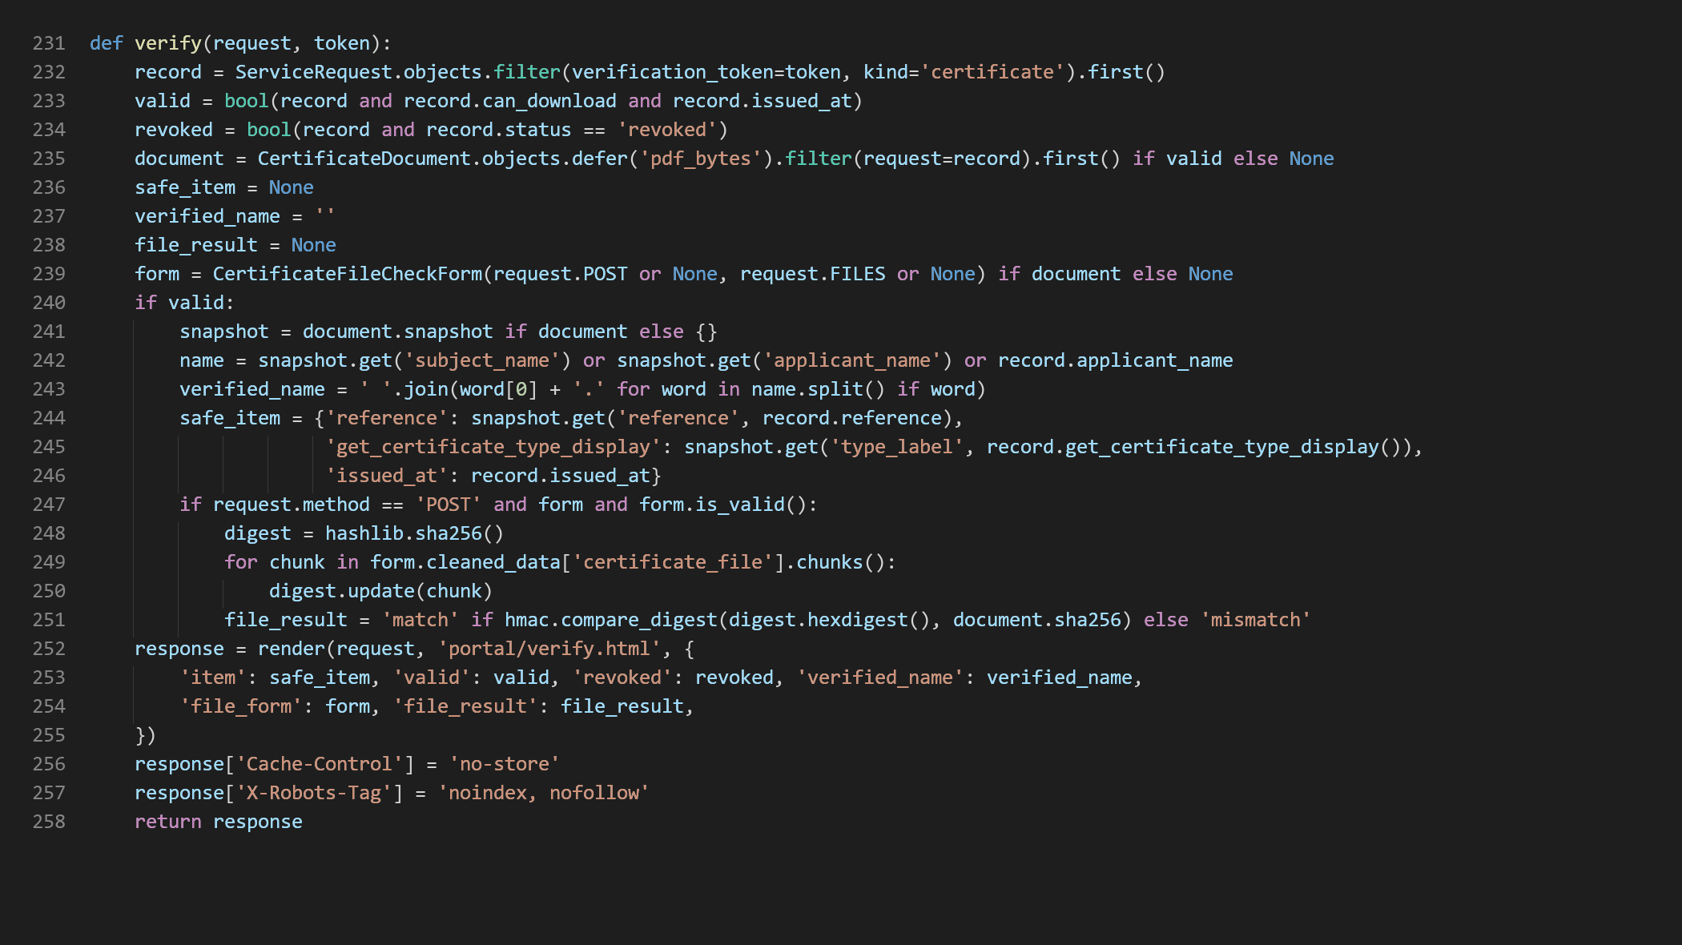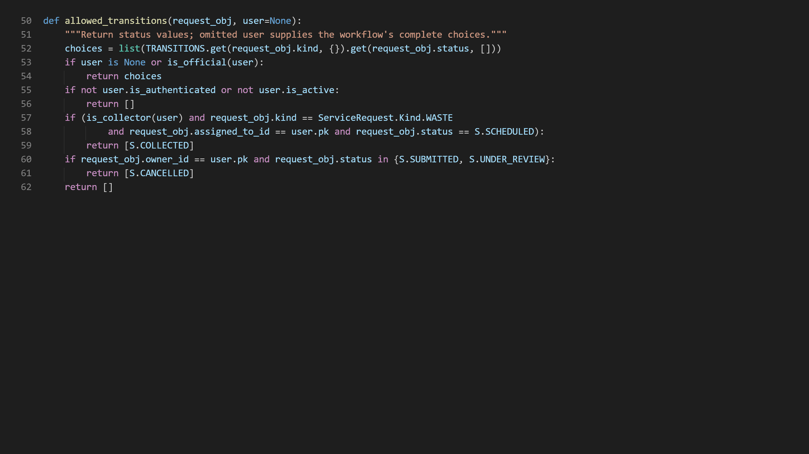

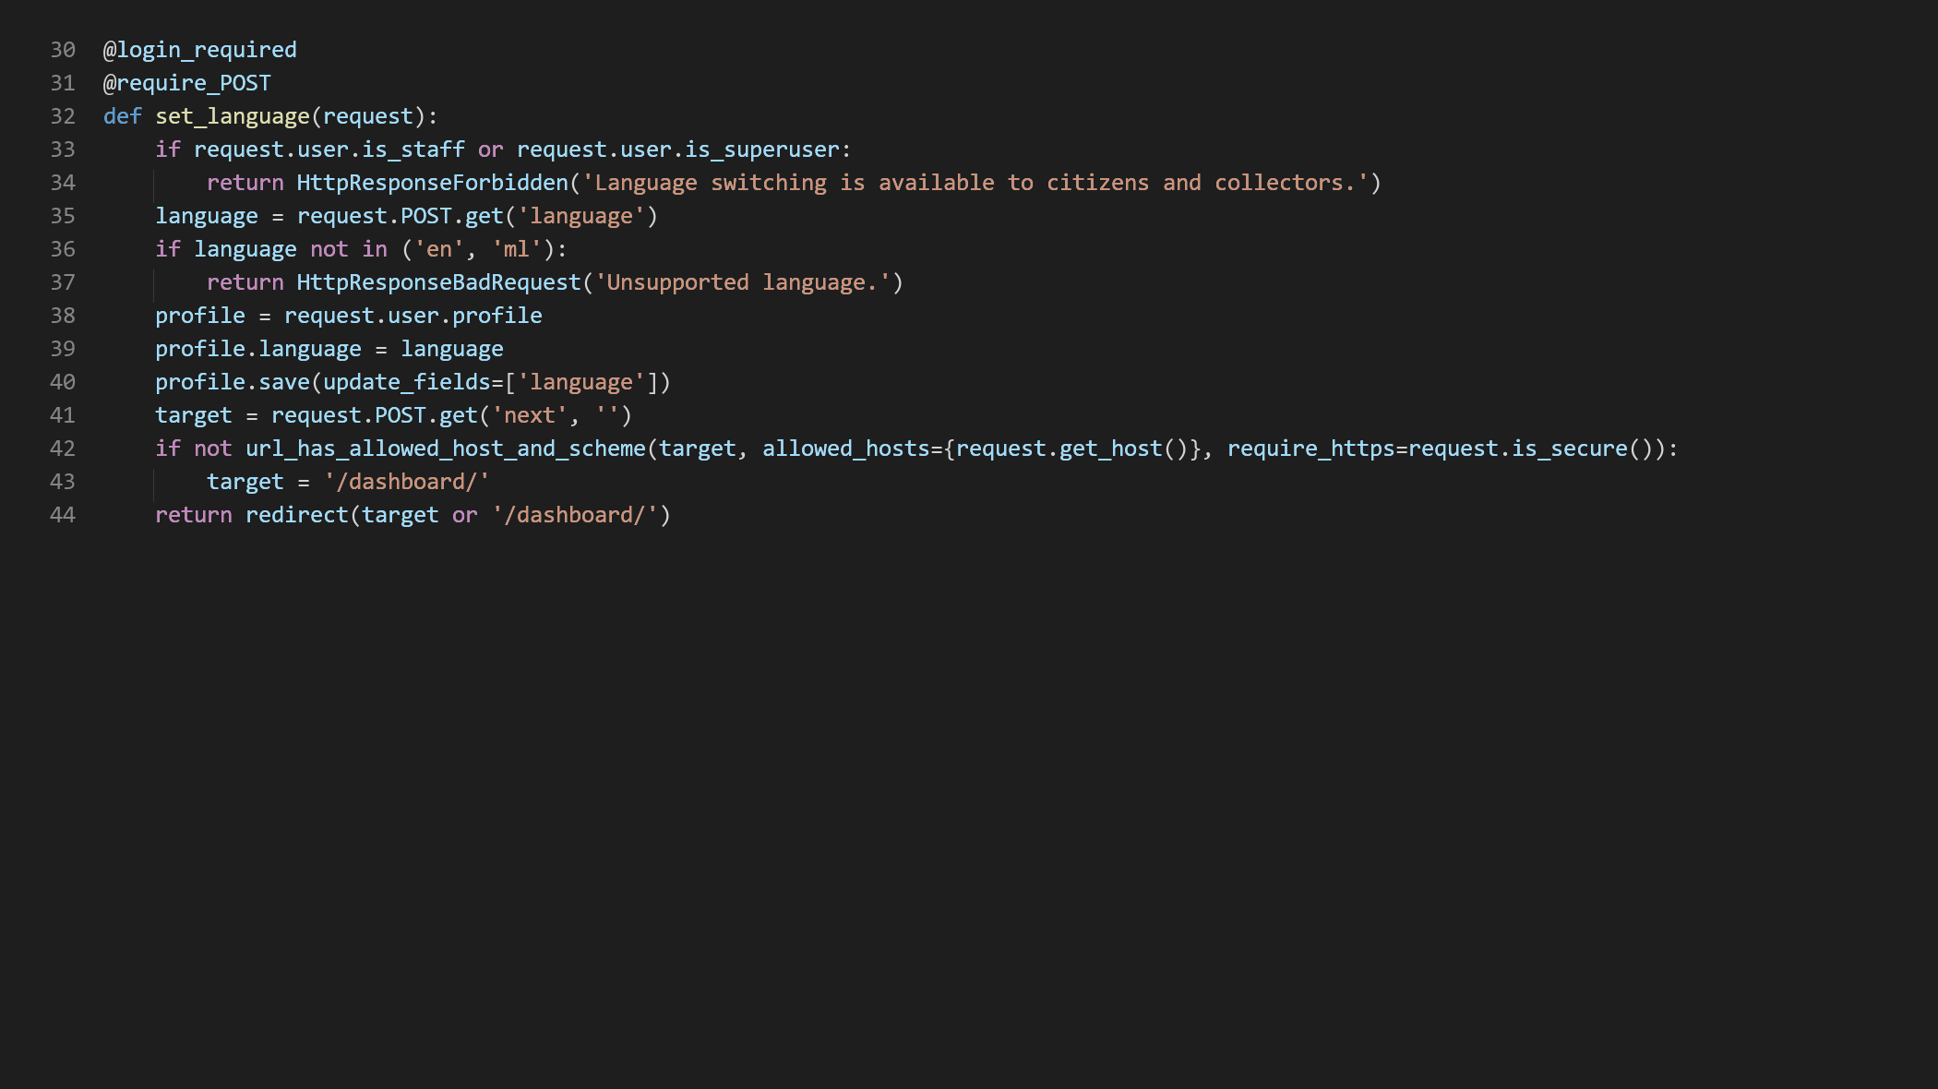
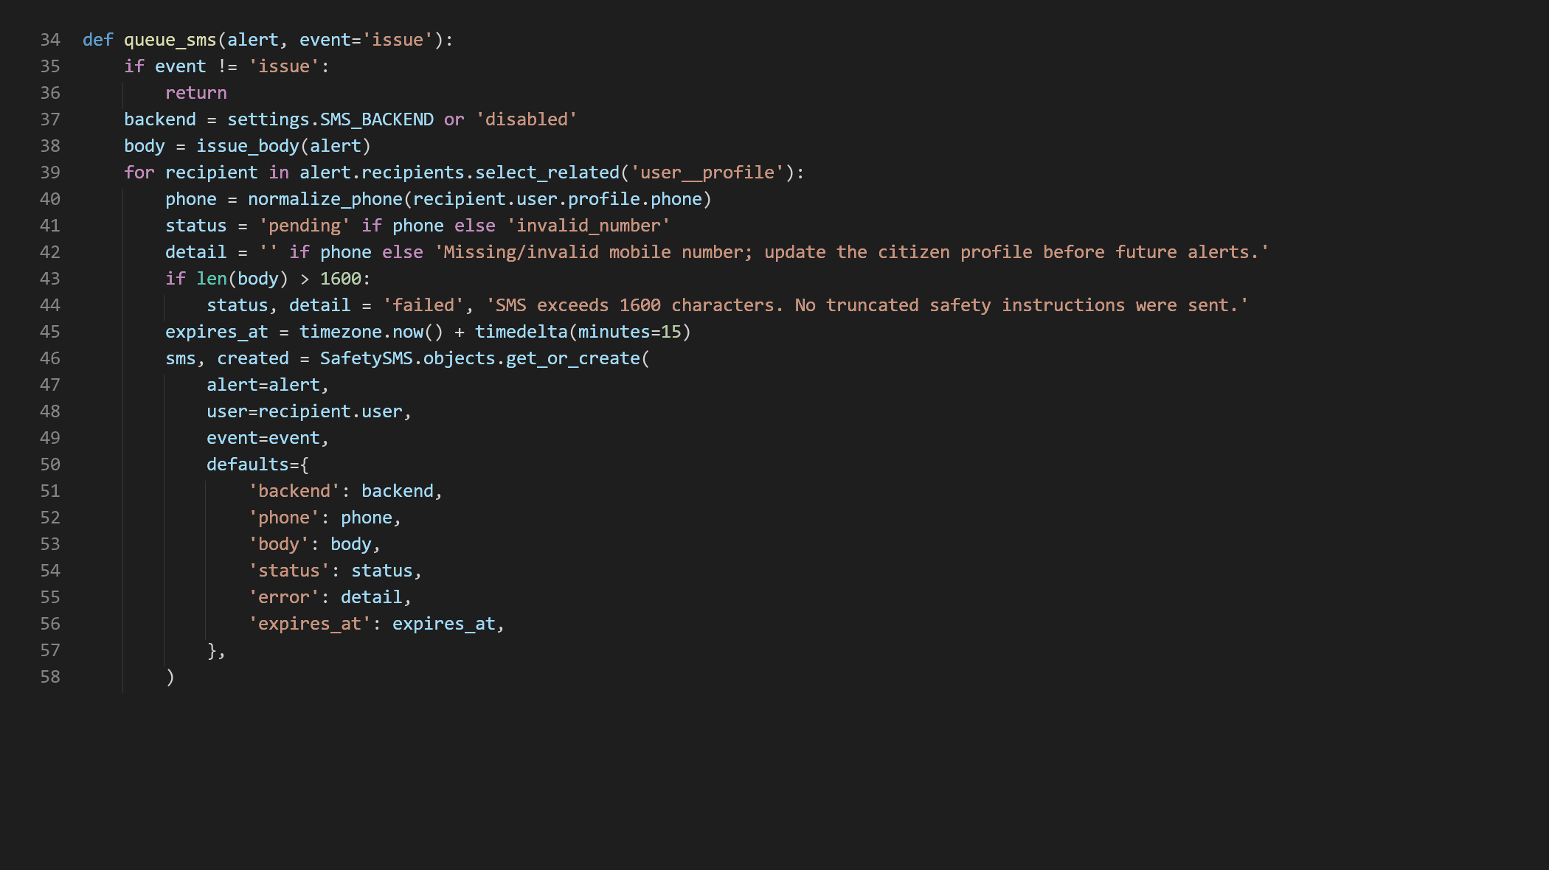

CHAPTER 11
REFERENCES
1. Dhamale, R., & Patil, V. (2025). Smart Governance in Rural India: Designing an E-Gram Panchayat System for Efficient Public Service Delivery. International Journal of Scientific Research and Computing.
2. Thorat, M., Jadhav, R., Kharade, J., Kudapane, M., & Nimse, R. (2023). E-Gram Panchayats: Enhancing Accountability and Transparency in Rural Administration. International Journal for Research in Applied Science and Engineering Technology, 11(11), 990-993. DOI: 10.22214/ijraset.2023.56258.
3. Fatmi, S. N., & Swalehin, M. (2022). Adoption of E-Governance Services among Rural People: An Assessment Study of Uttar Pradesh. Journal of Exclusion Studies, 12(2), 163-174. DOI: 10.5958/2231-4555.2022.00012.2.
4. Roy, M. N. (2022). Promoting E-Governance in Panchayats. Journal of Rural Development, 40(2). DOI: 10.25175/jrd/2021/v40/i2/168044.
5. Thottunkel, A. K., & Kuppathanath, S. V. (2015). ICT-based reforms in local government decision-making in the gram panchayats of Kerala. Commonwealth Journal of Local Governance, 16/17.
6. Kamble, R. R., Suriya, A. Y., & Kishor, S. B. (2025). Improving Rural E-Governance in India: Challenges, Strategies, and a Proposed Framework. International Journal on Science and Technology, 16(2). DOI: 10.71097/IJSAT.v16.i2.5430.
7. Chougule, S., Hulyalkar, H. S., Nayak, D., Mulik, P., & Khade, S. (2026). DigiGram: An AI-Powered Digital Governance Platform for Rural Panchayats in India. Multidisciplinary Journal of Research in Engineering and Technology, 13(1), 133-142. DOI: 10.65521/mjret.v13i1.3107.
8. Borchate, Y. B., Date, R. A., Gage, S. R., & Gawali, A. M. (2026). AI-Based E-Gram Panchayat System. International Journal for Research in Applied Science and Engineering Technology. DOI: 10.22214/ijraset.2026.78363.
9. The Encryption of Electronic Professional Certificate by Using Digital Signature and QR Code. (2021). IEEE Conference publication. DOI: 10.1109/ICCTEIE54047.2021.9650641.
10. Barkley, J., Kuhn, D., Rosenthal, L., Skall, M., & Cincotta, A. (1998). Role-Based Access Control for the Web. National Institute of Standards and Technology (NIST).
11. Ministry of Panchayati Raj, Government of India. e-GramSwaraj - official project information and architecture.
12. Press Information Bureau, Government of India. (2026). Digital Transformation of Panchayati Raj Institutions (PRI), Ministry of Panchayati Raj.
13. National Informatics Centre. (2026). eGramSwaraj: Empowering Rural India through Digitisation in Panchayats.
14. Django Software Foundation. Django Documentation - Authentication, ORM, Forms, CSRF Protection and File Uploads.
15. Python Software Foundation. Python 3 Documentation.
16. Oracle Corporation. MySQL 8.0 Reference Manual.
17. ReportLab. ReportLab PDF Toolkit Documentation.
18. qrcode Python package documentation and project repository.
19. Cozmo / jsQR project. JavaScript QR code reading library documentation and source.
20. Bootstrap Documentation. Responsive web layout and components.
21. OWASP Foundation. Cross-Site Request Forgery Prevention Cheat Sheet.
22. OWASP Foundation. File Upload Cheat Sheet.
23. OWASP Foundation. Authorization Cheat Sheet.
24. NIST. Secure Software Development Framework (SSDF), SP 800-218.
25. United Nations. Sustainable Development Goals: Goals 9, 11, 13 and 16.
